**Installing an Arduino Through I2C**

*No Logic-Level Converter*

(Refer to the back for pin numbers)

**The First Step: Connecting the Cables**

First we will tie the ground of the Raspberry Pi to the ground of the Arduino Uno, it will look something like this:

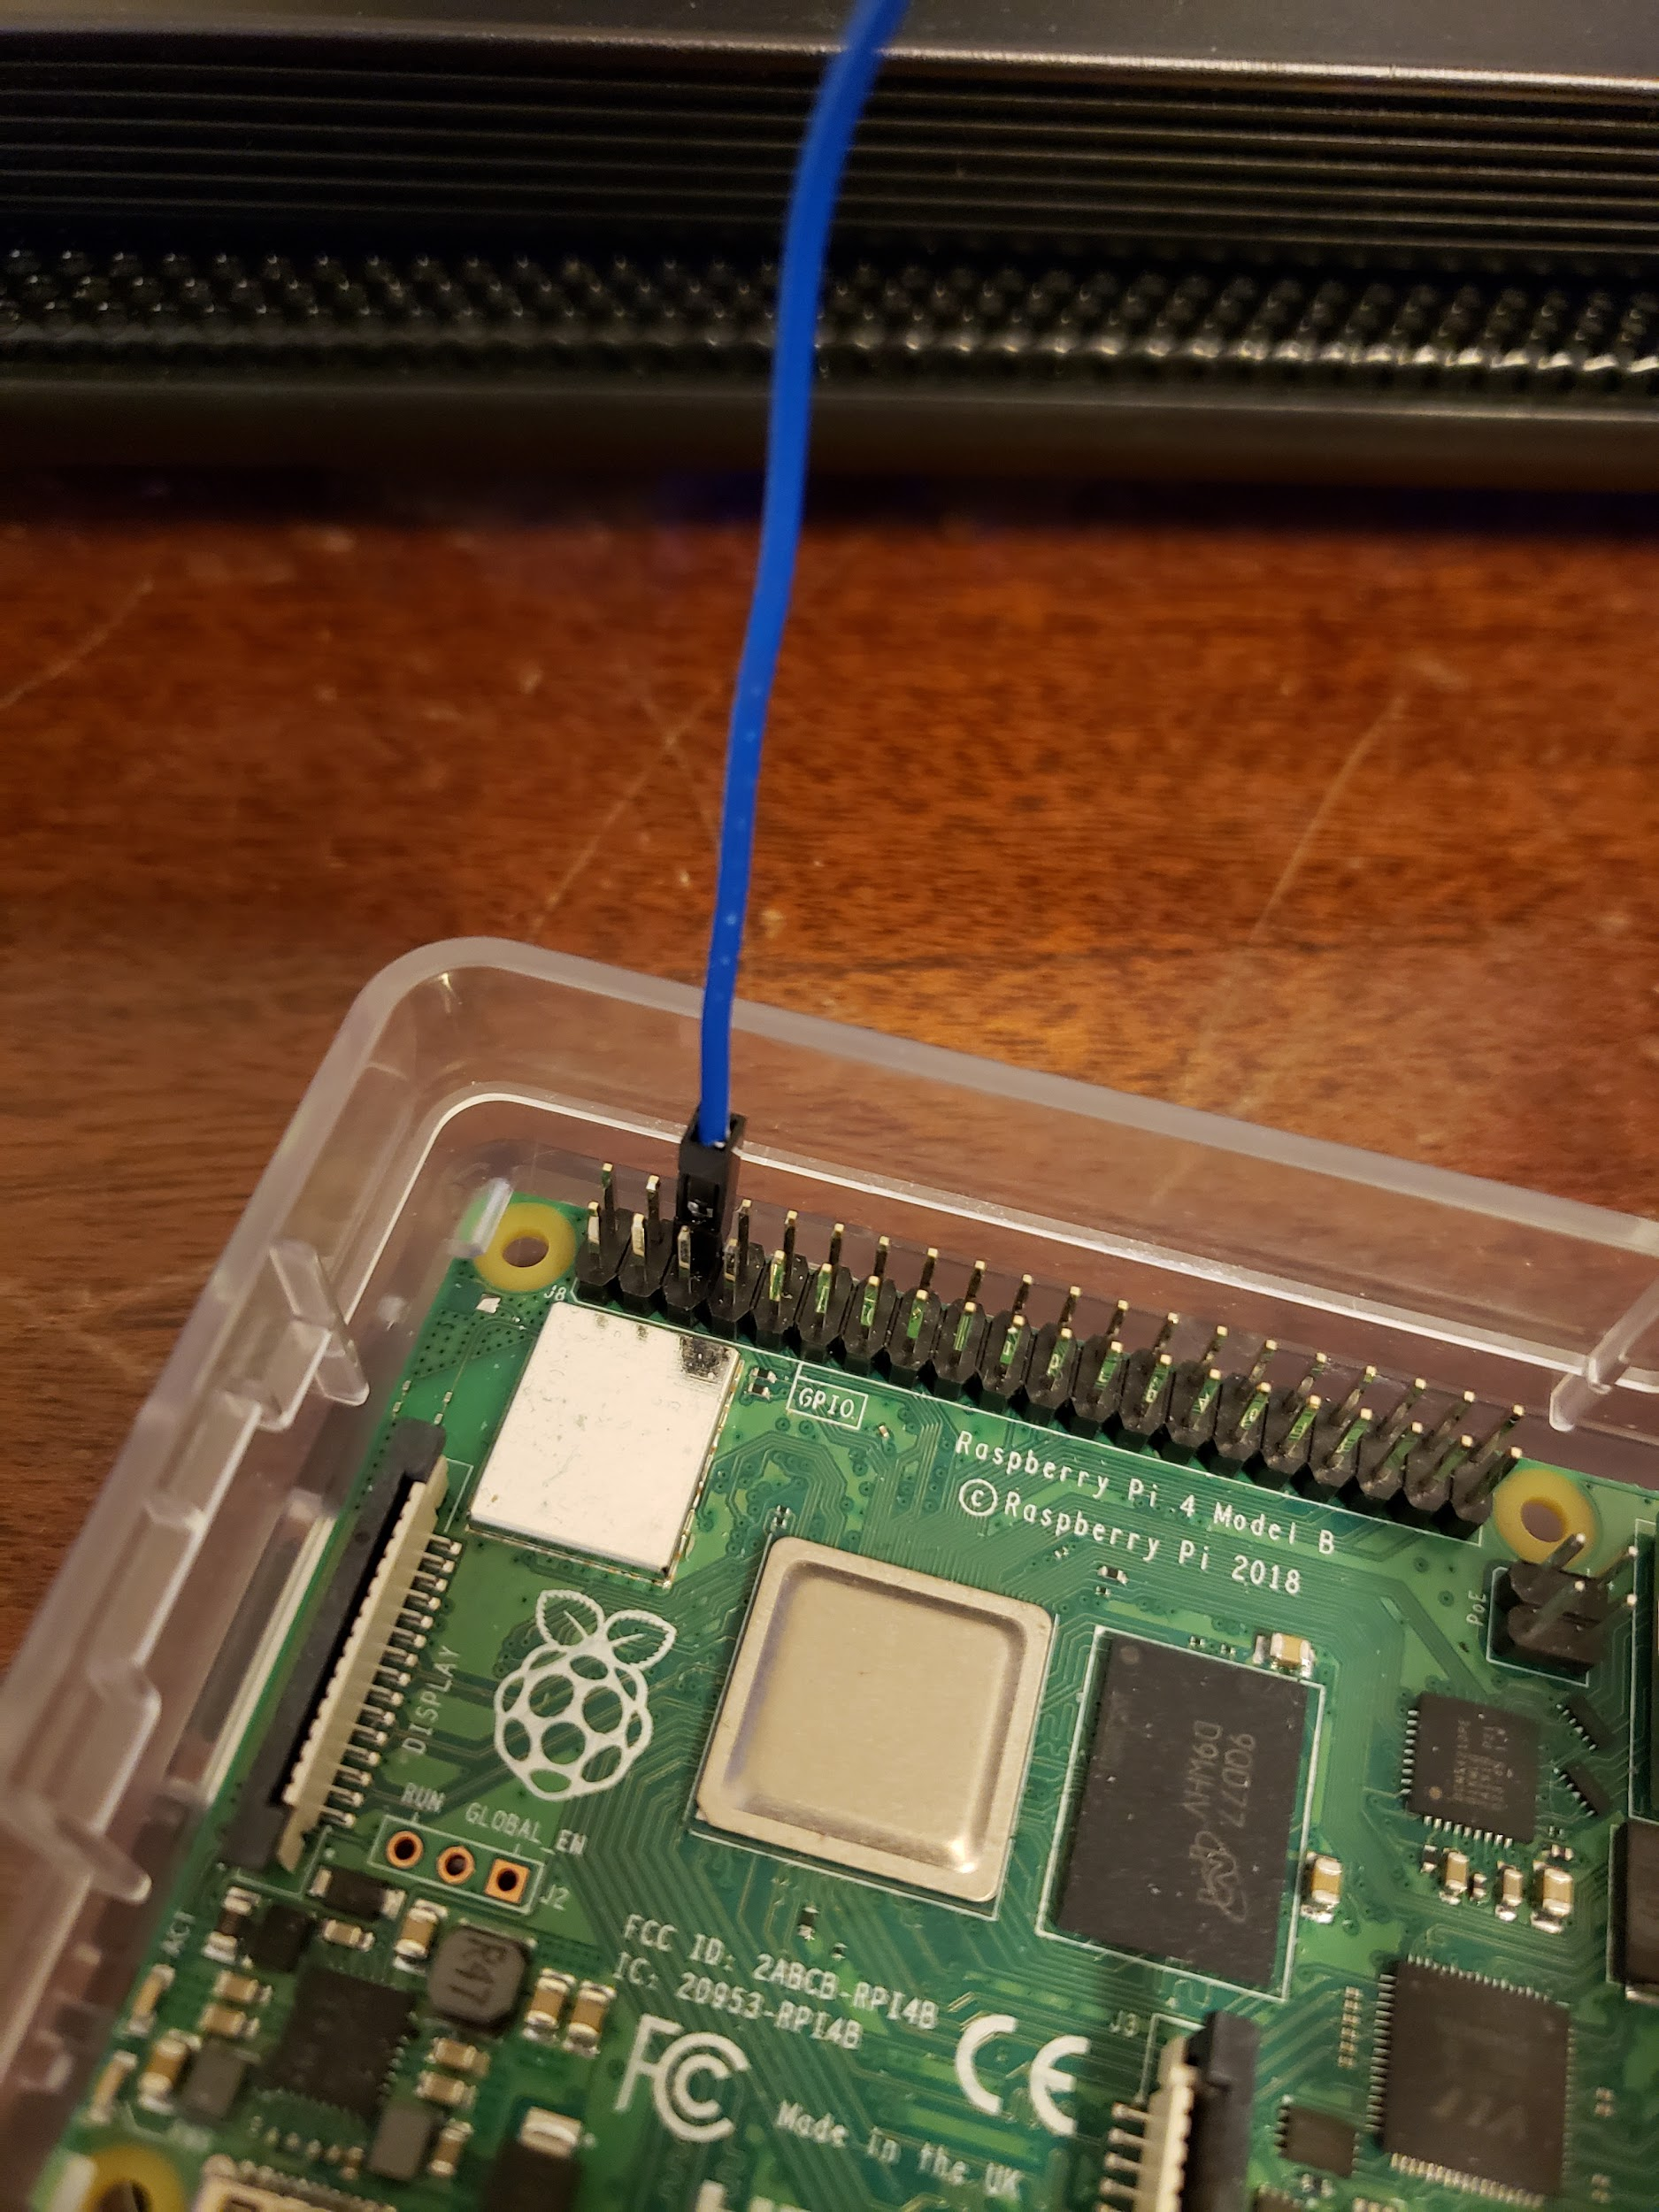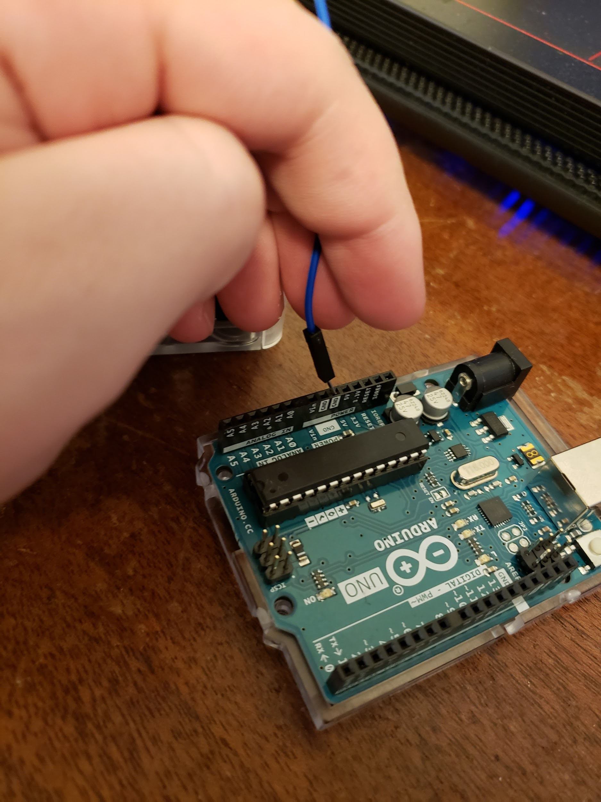

(I chose the ground on pin 6)

Next we will connect the I2C SCL pin, this is pin 5 on the Raspberry Pi, connect this to pin A5 on the arduino.

It will look something like this:

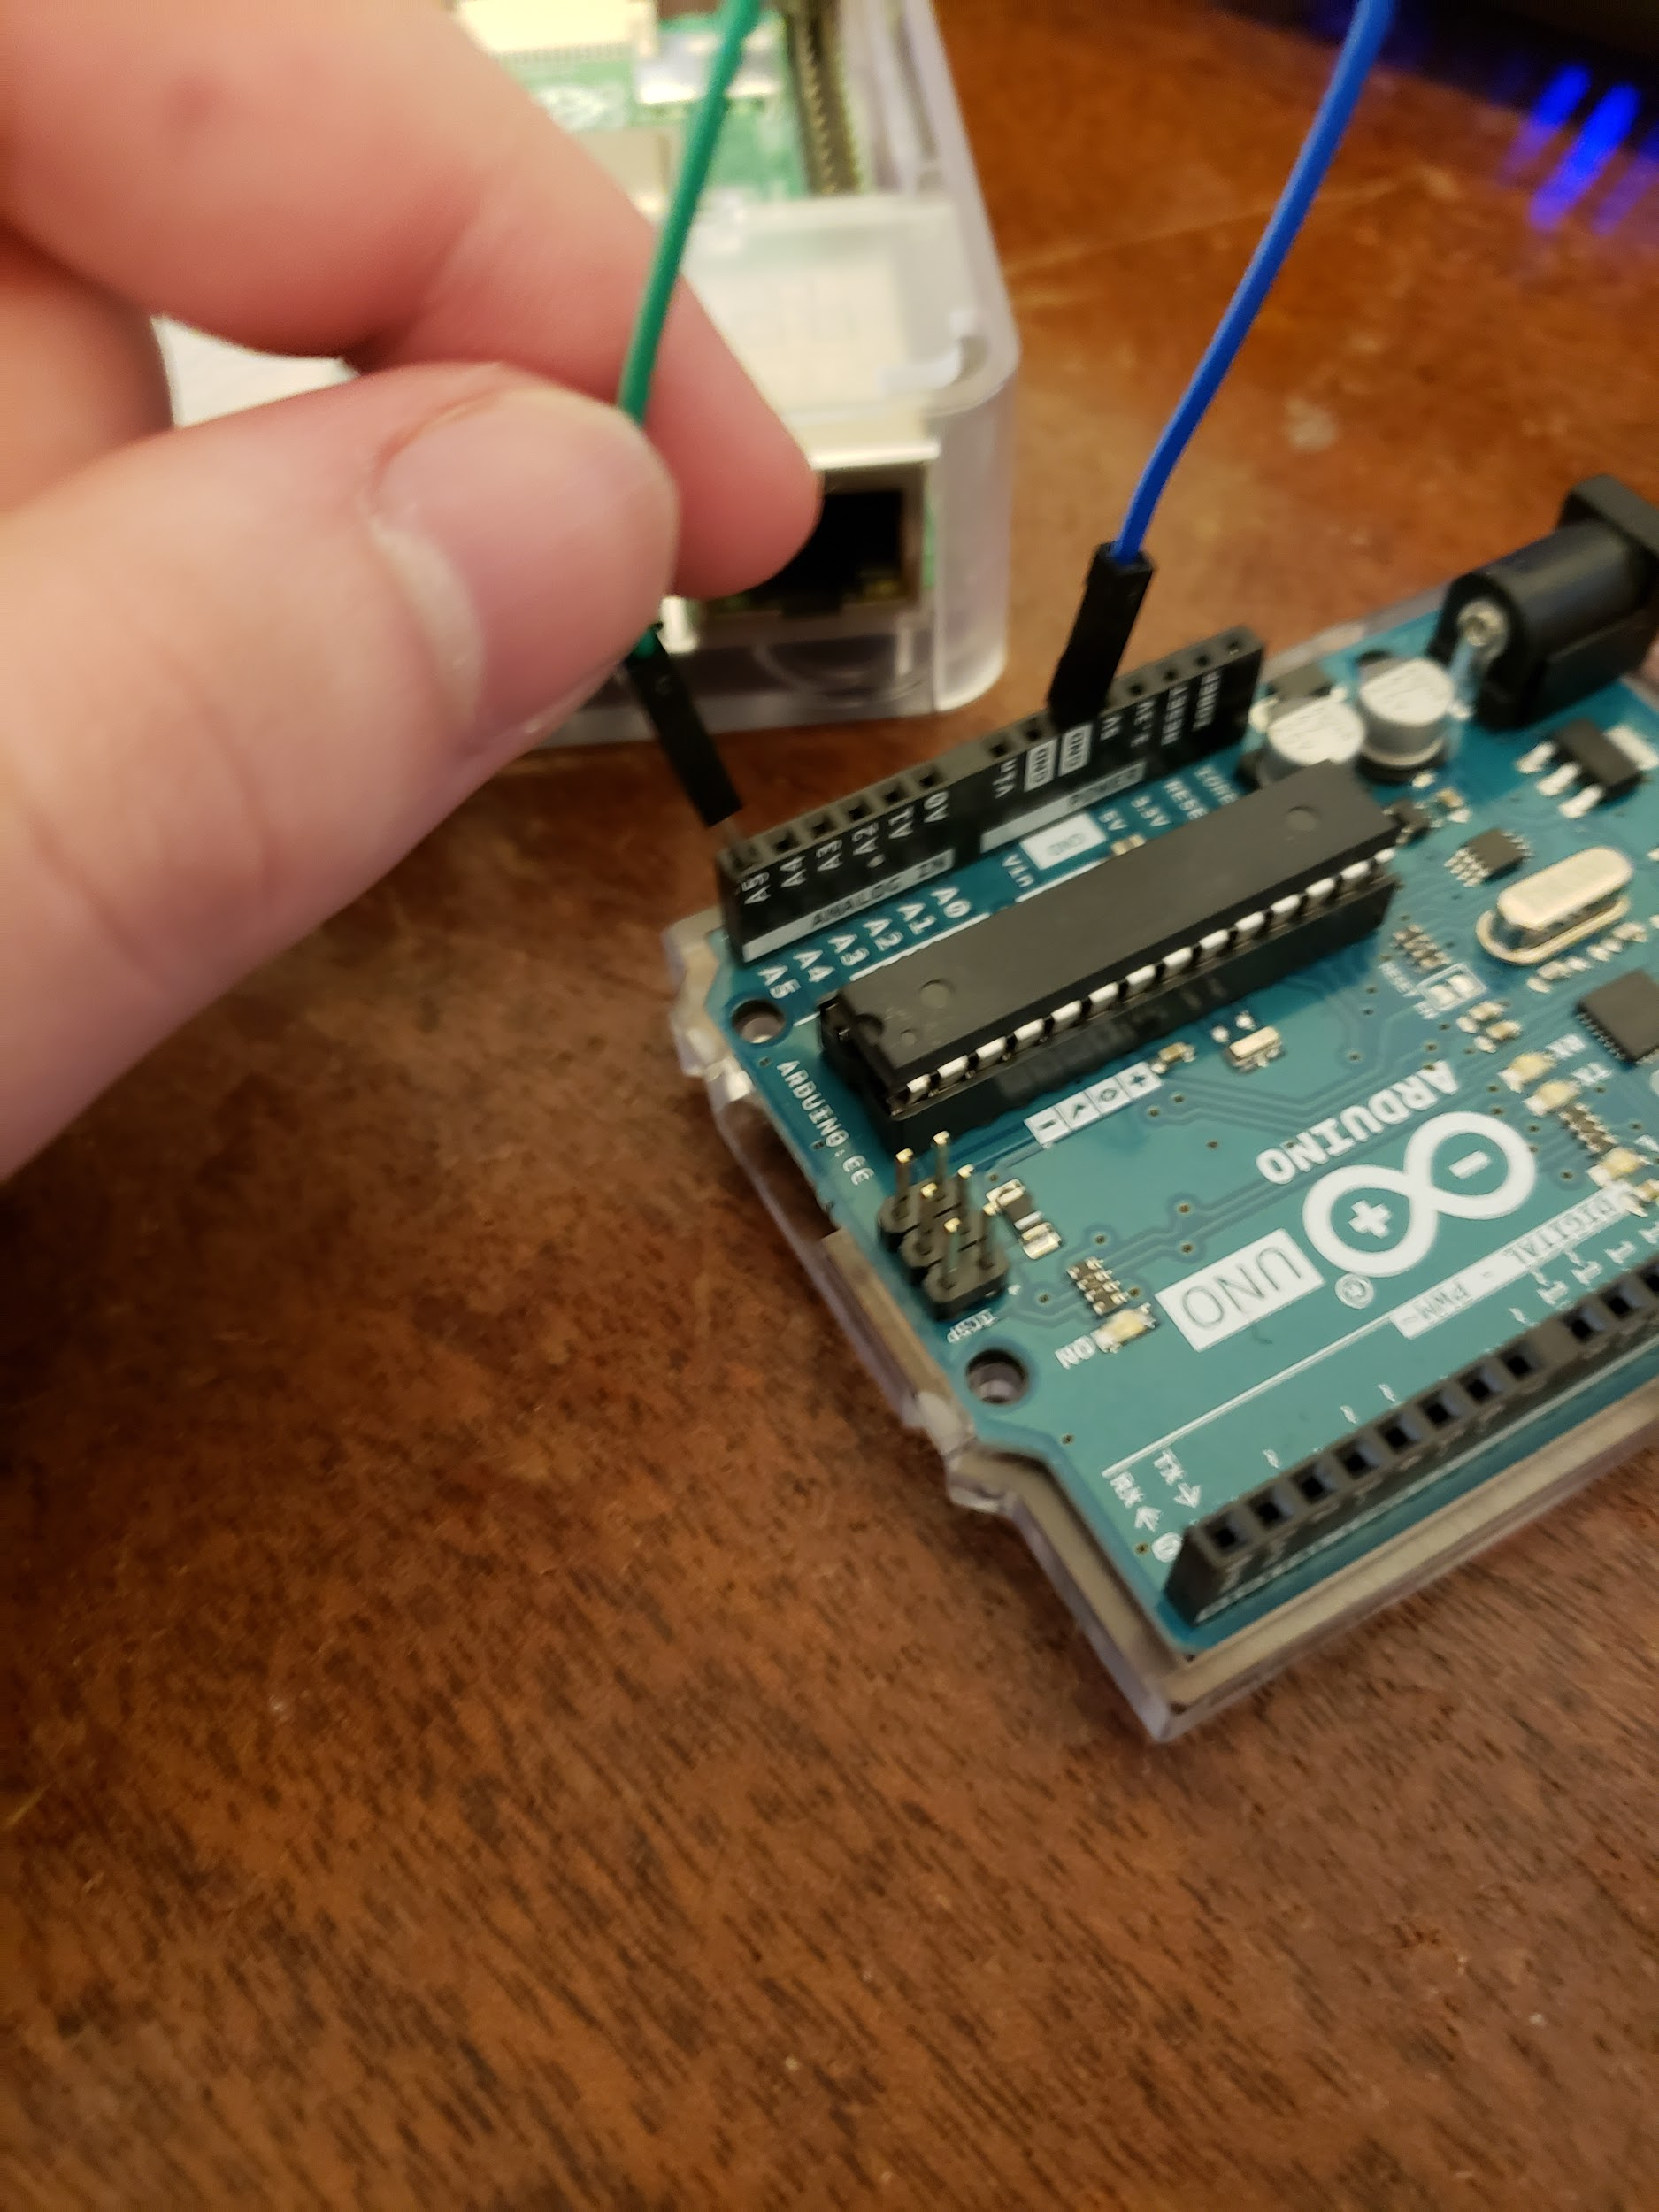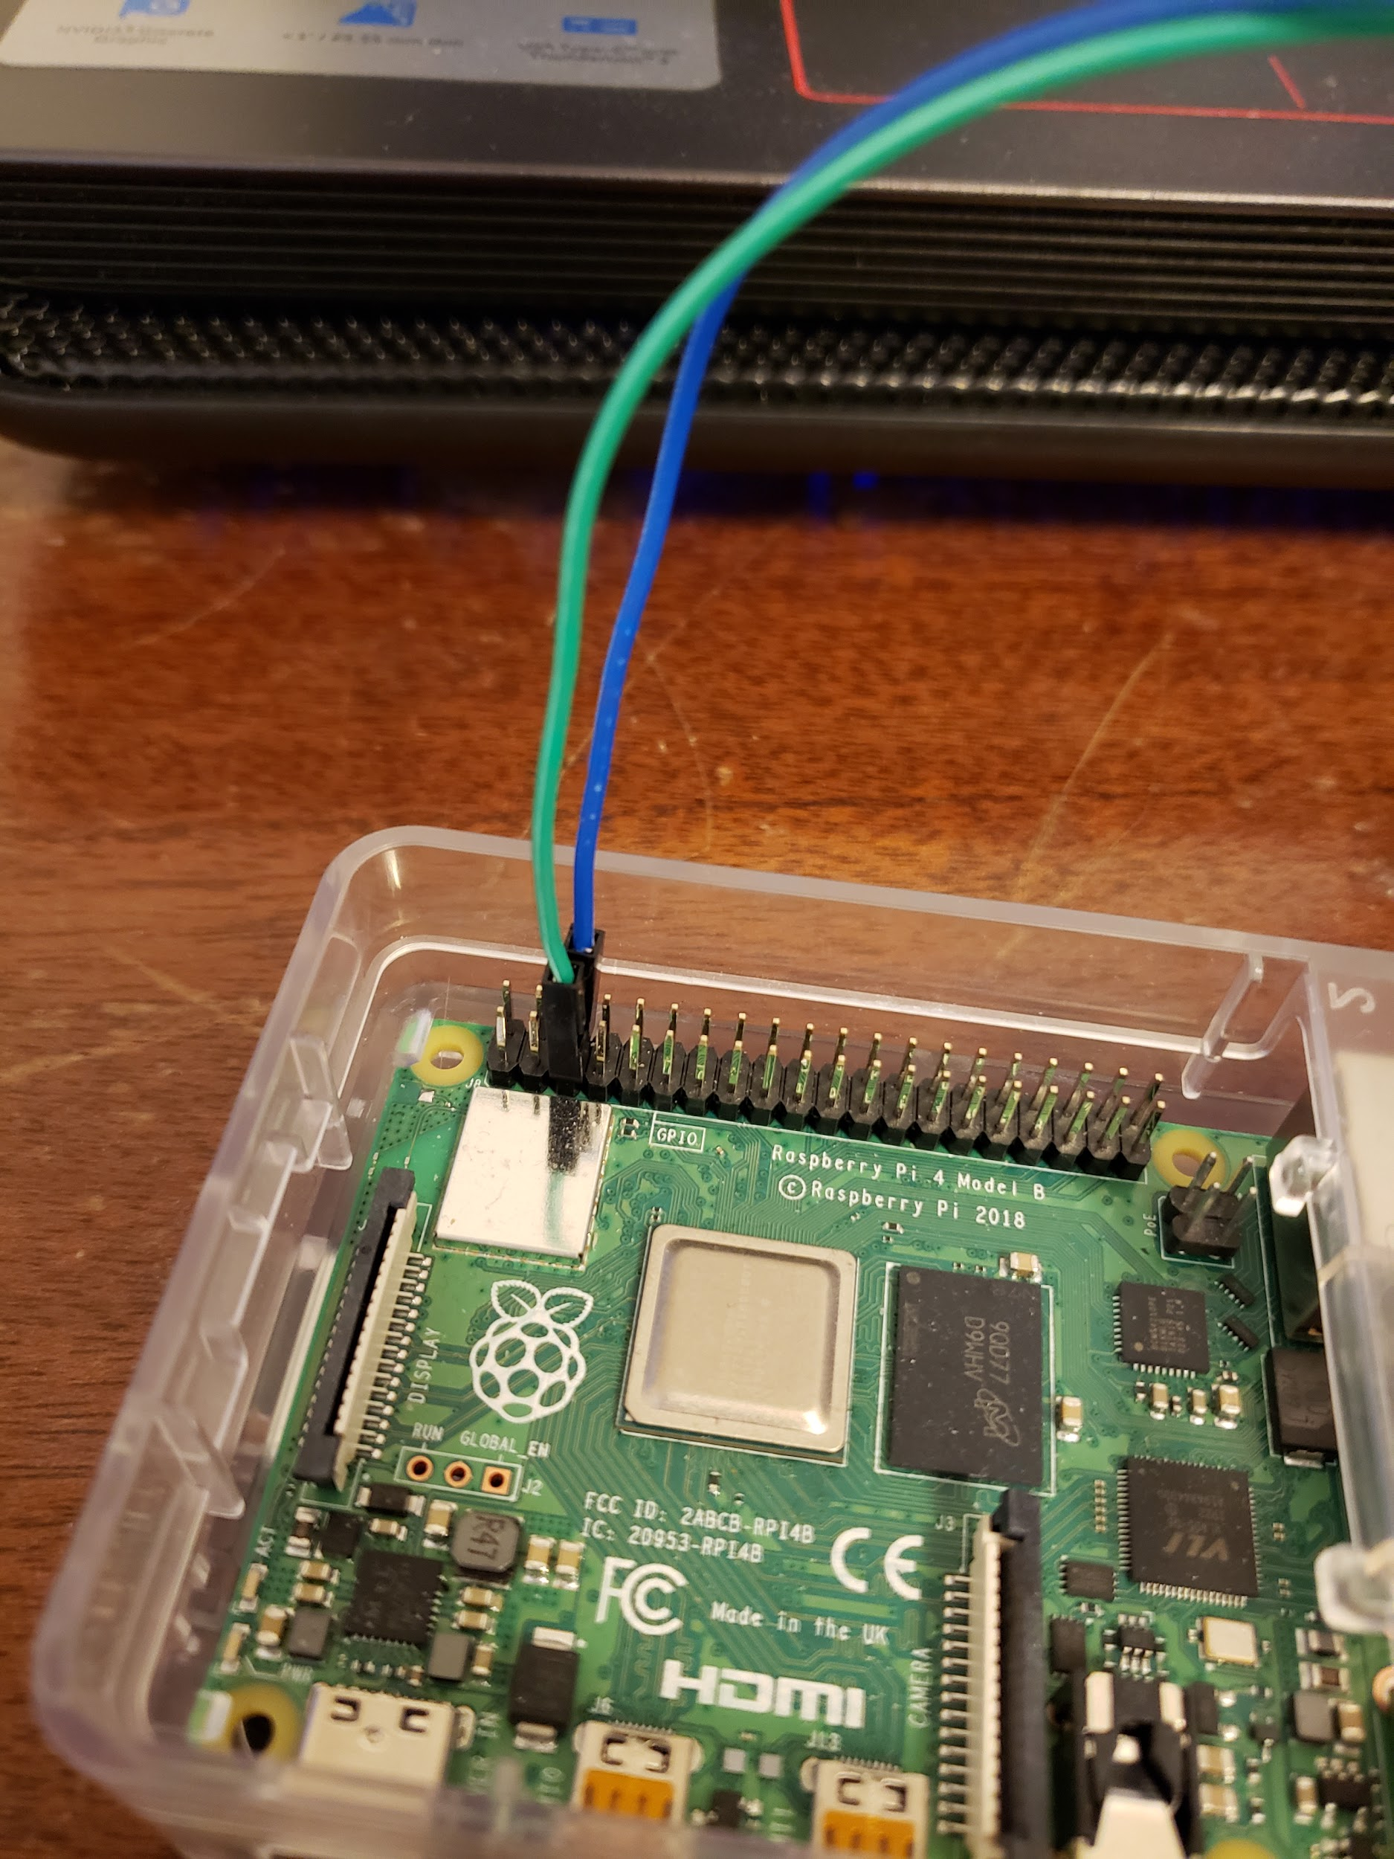

After this we will connect the I2C SDA pin, this is pin 3 on the Raspberry Pi, we will connect this to pin A4 on the Arduino. It will look something like this:

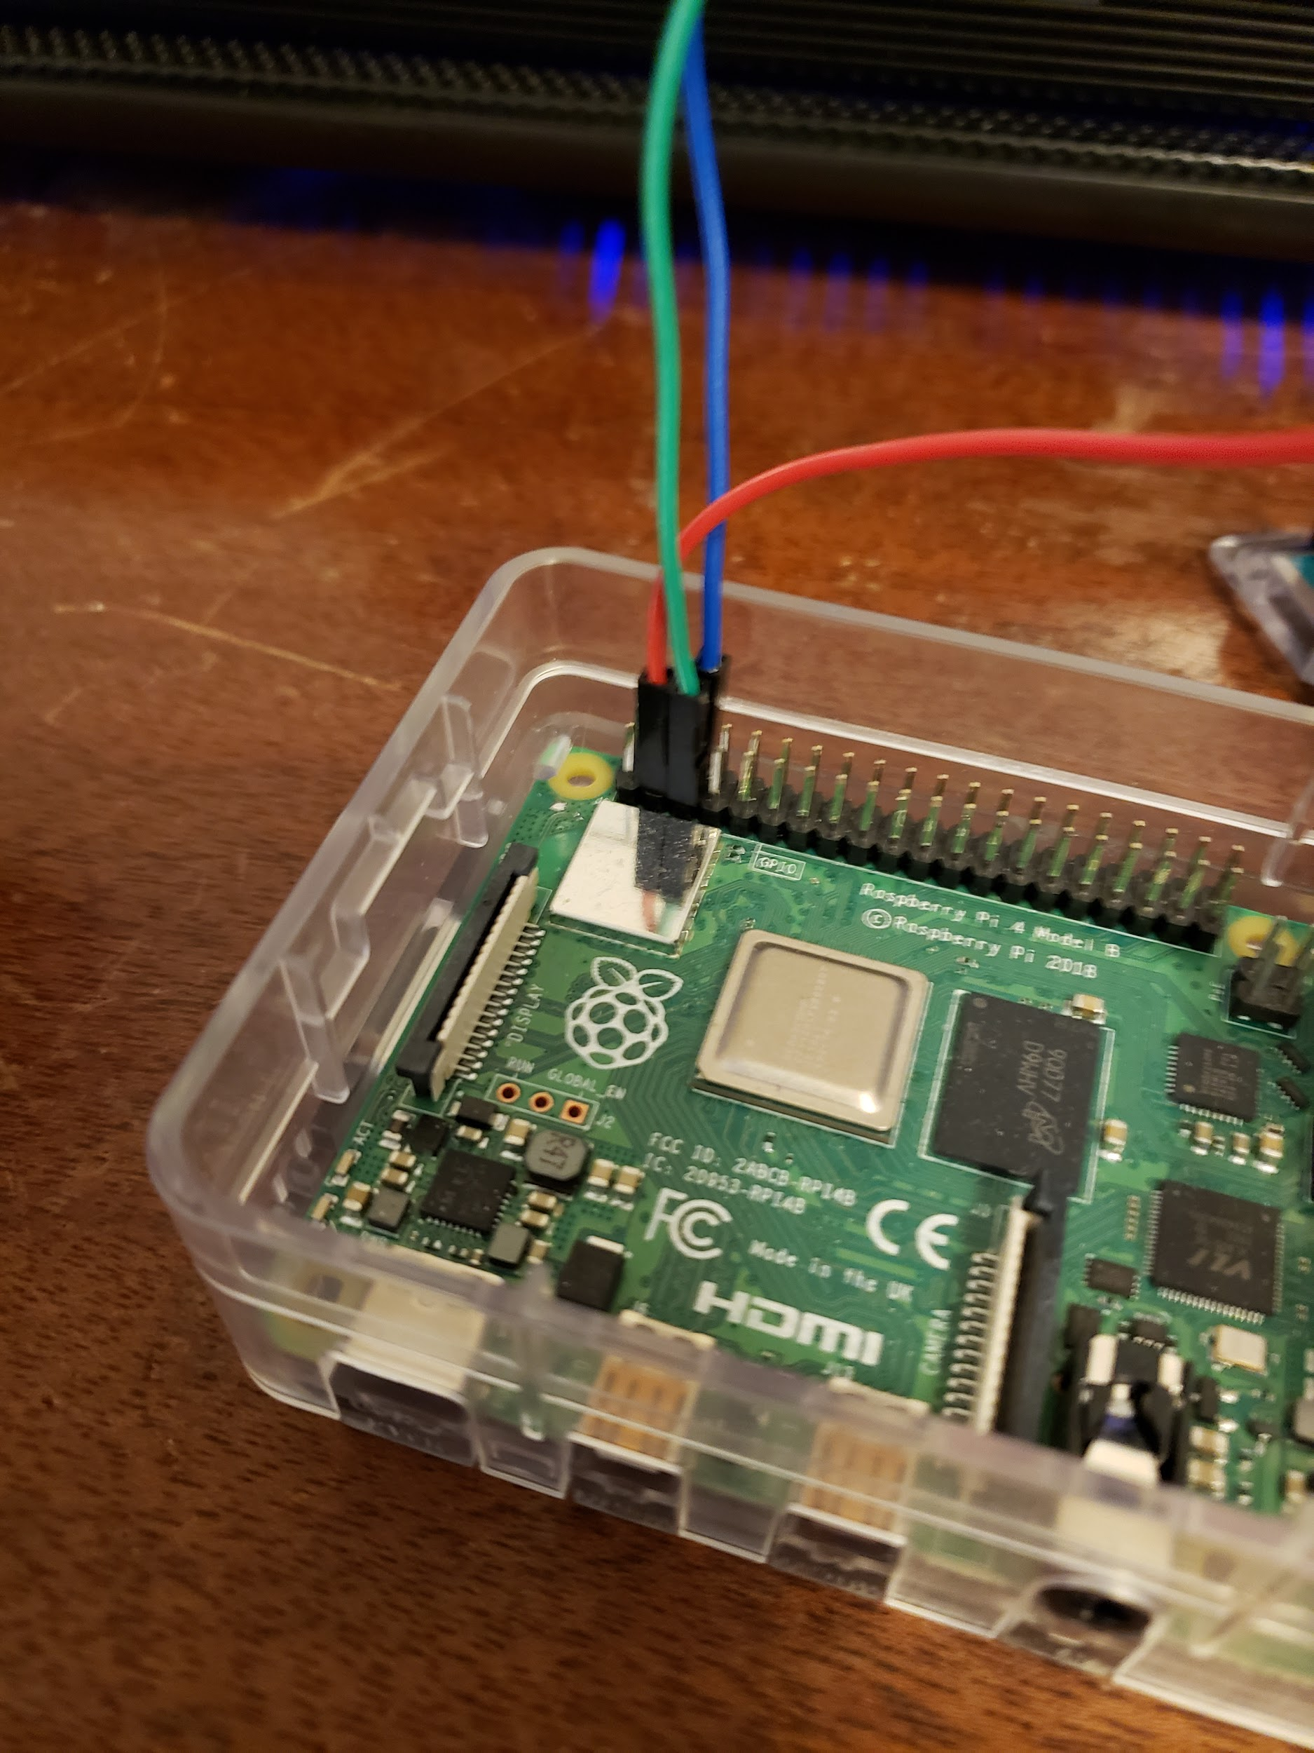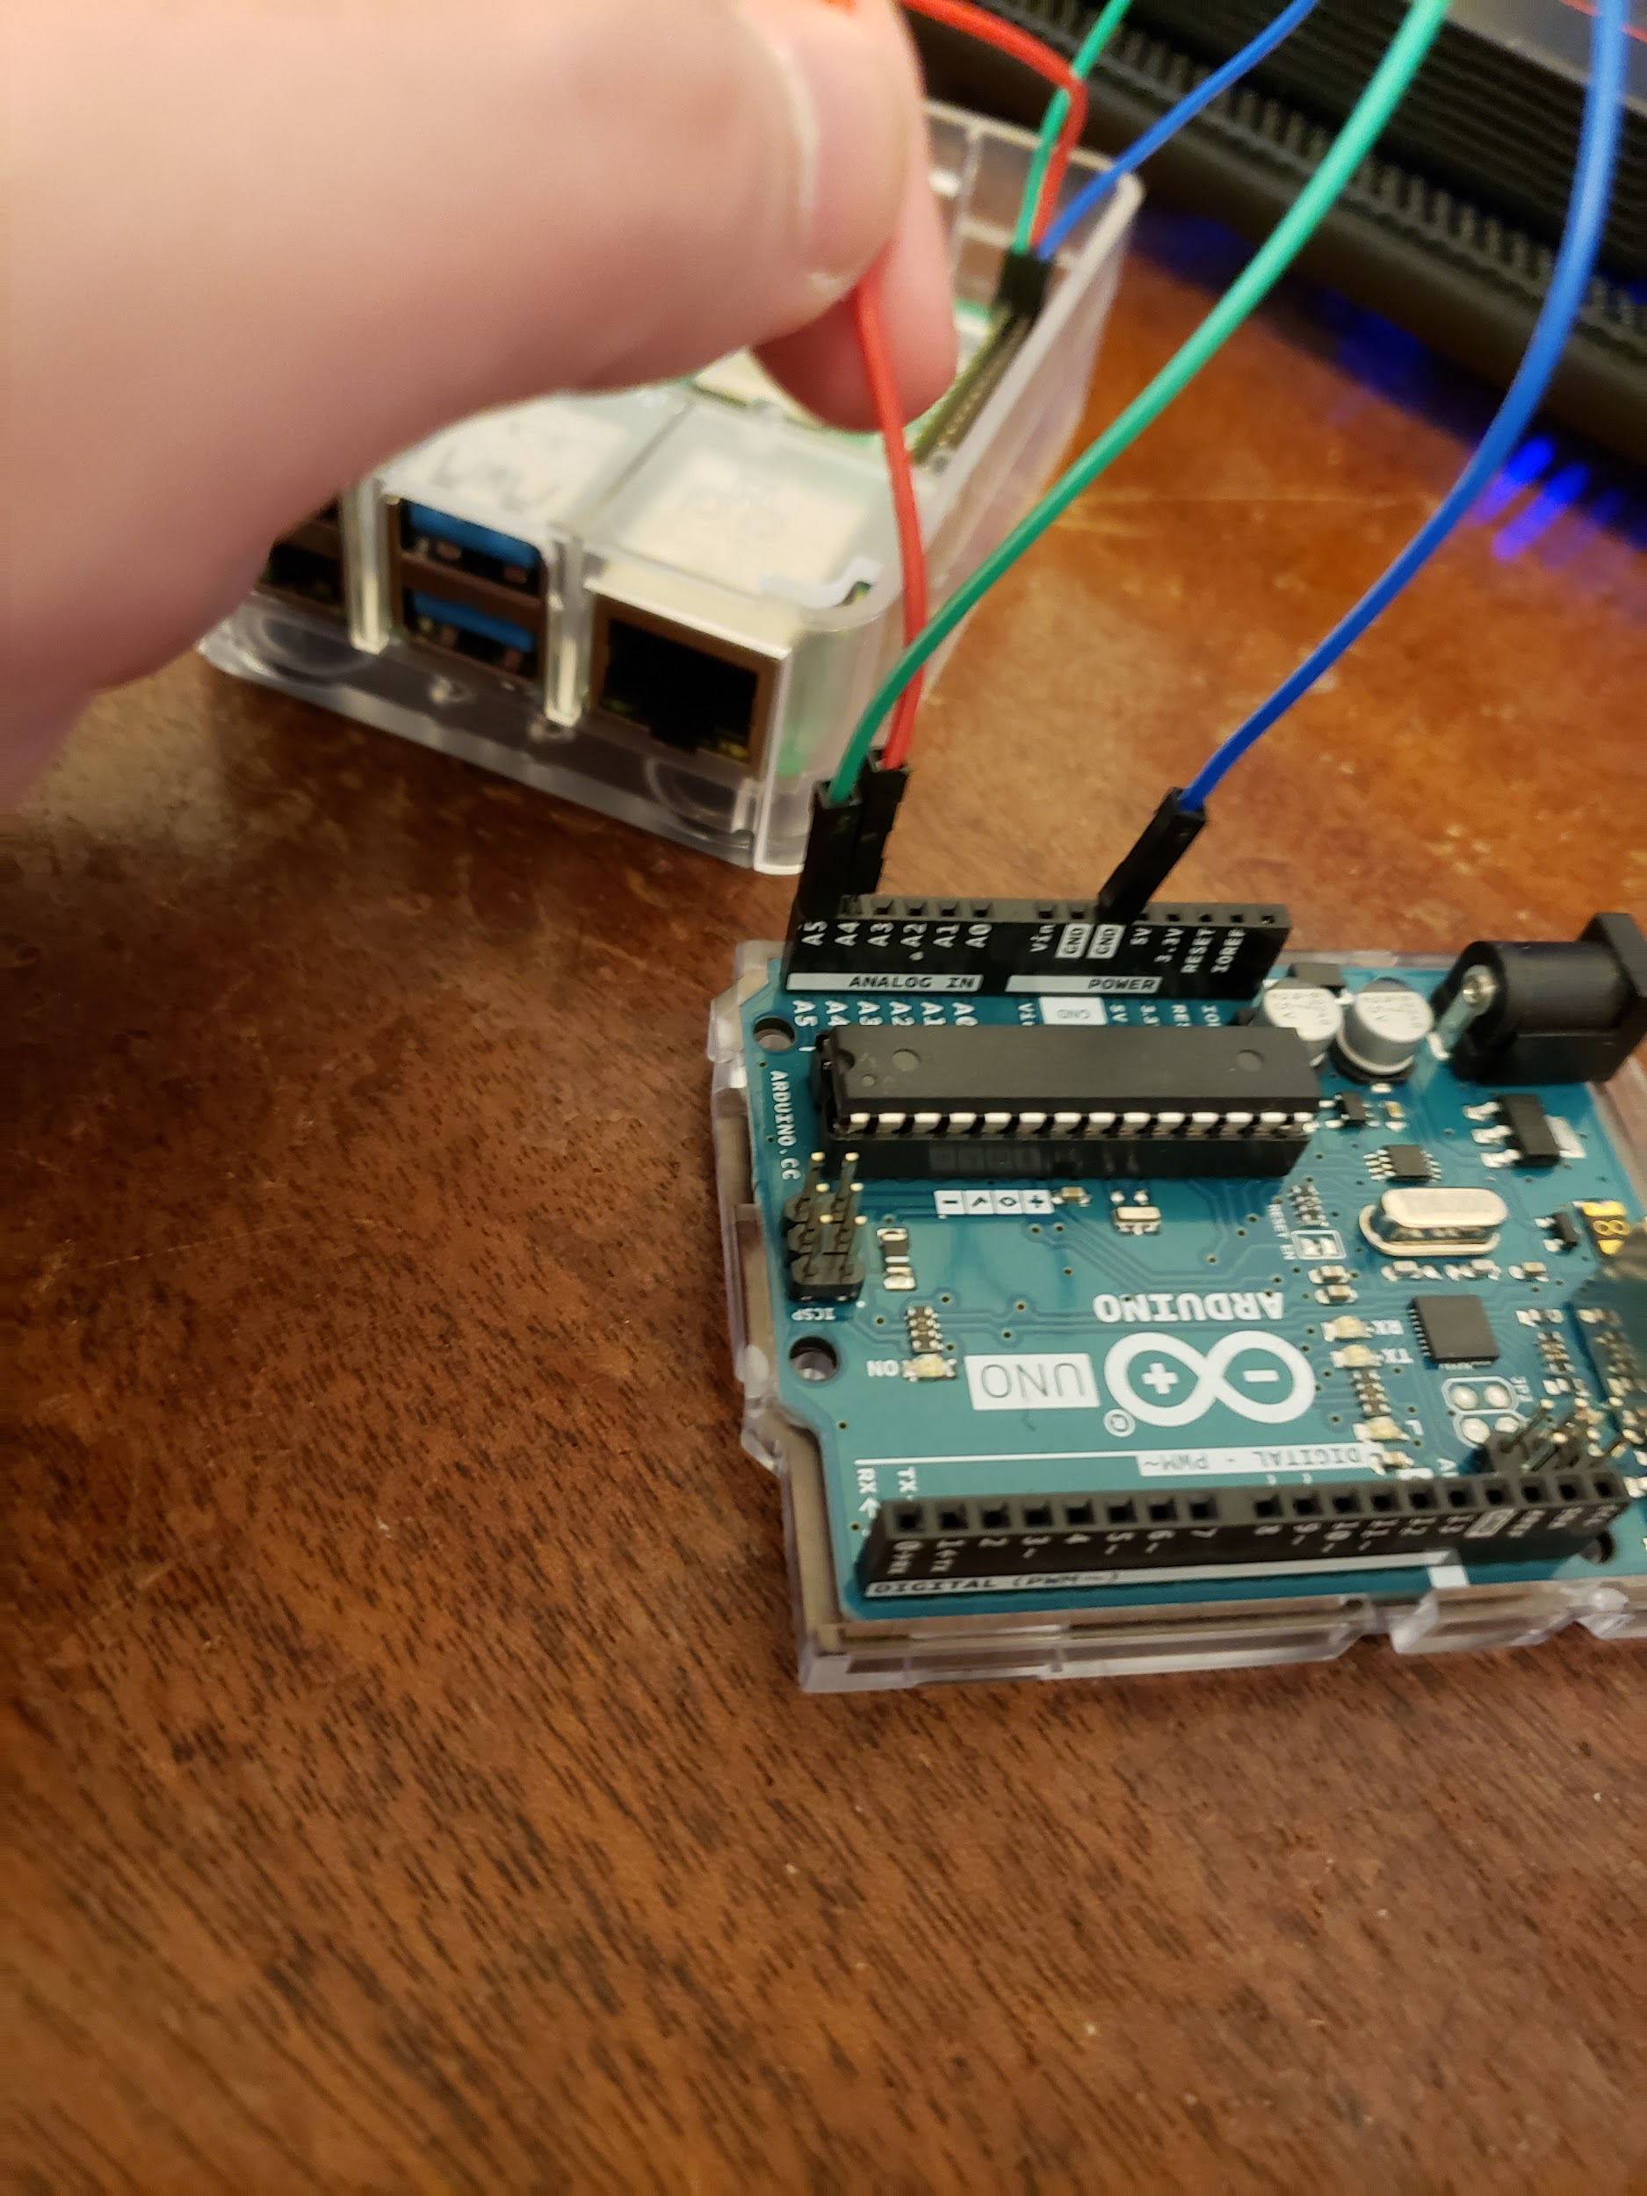

Next, let’s give our Arduino some power, and the ability to upload files onto it. Connect a USB cable between the two devices. For the Raspberry Pi, simply connect a type-A connector into any of the available ports. Then plug the type-B connector into the corresponding port on the Arduino. It should look something like this:

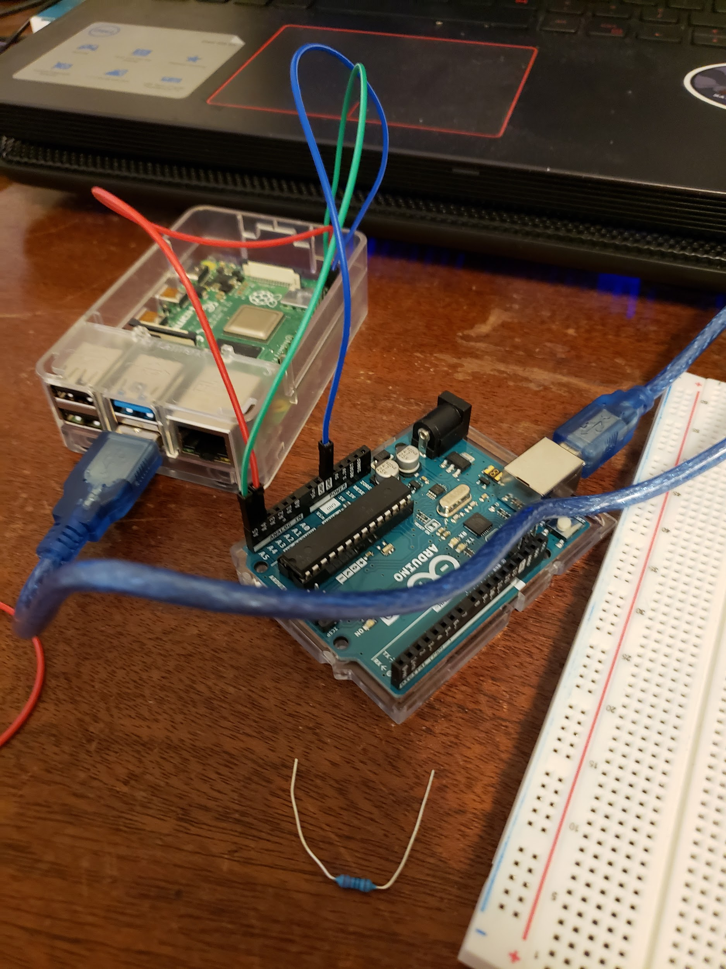

To make sure everything is connected properly, we will connect an LED on to the Arduino, and write a simple program that can turn it on or off depending on an input from the user. The first step for this is to plug a 220 ohm resistor into pin 13 of the Arduino, that leads into the positive terminal of a breadboard. It should look something like this:

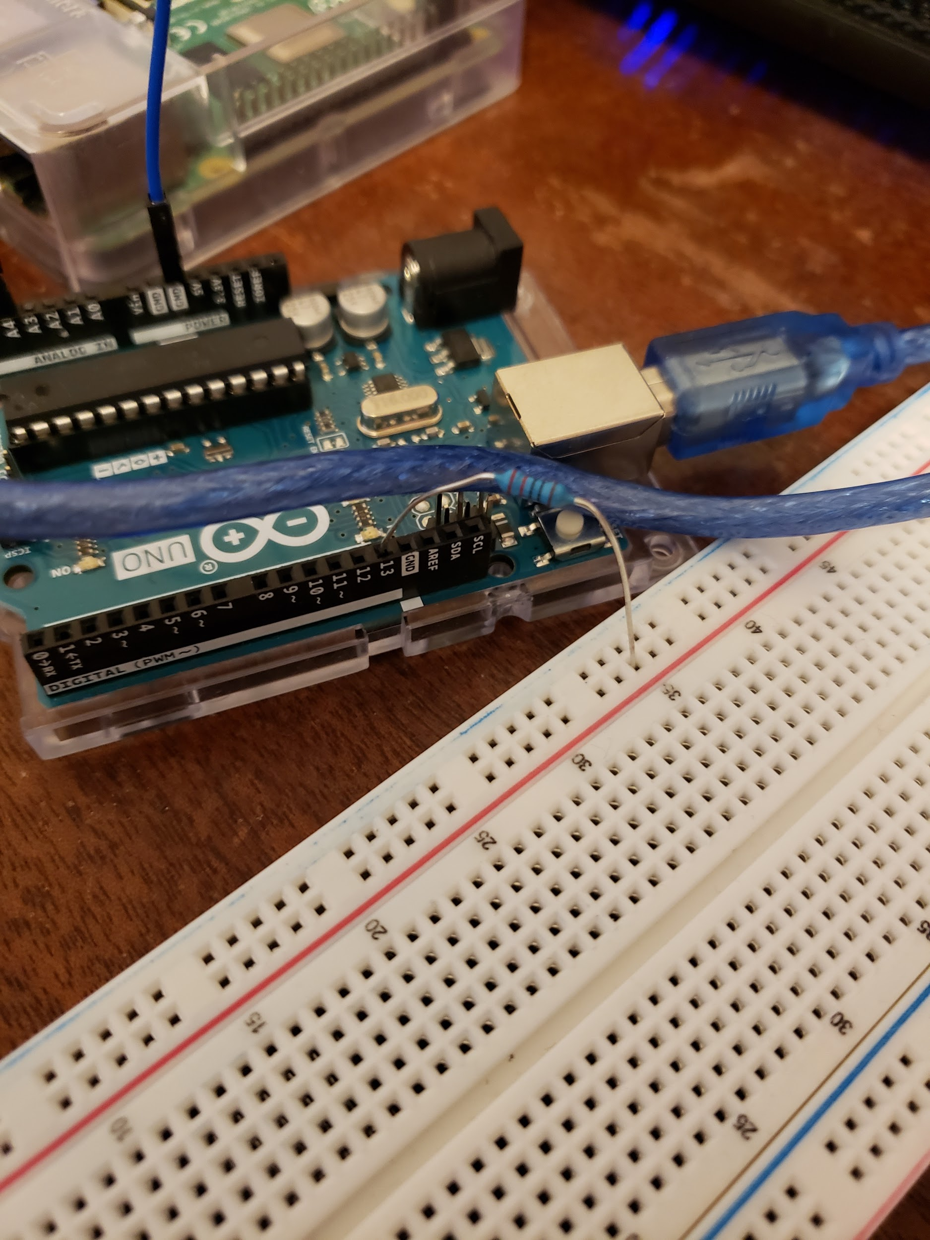

Next we will plug the LED into the breadboard, first connect the anode (long pin) anywhere on the positive terminal, then plug the cathode into the negative terminal. It should look something like this:

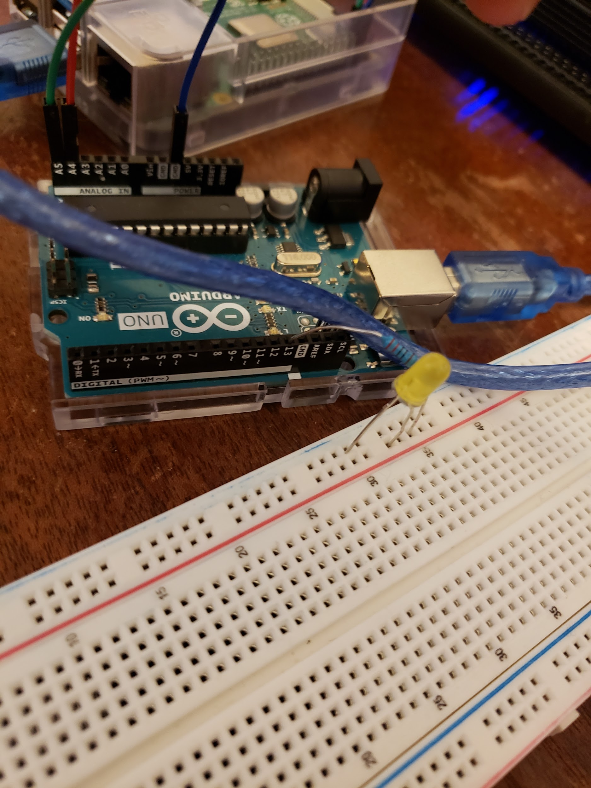

For the next step we will simply run a jumper cable from the negative terminal to the ground on the Arduino, it should look something like this:

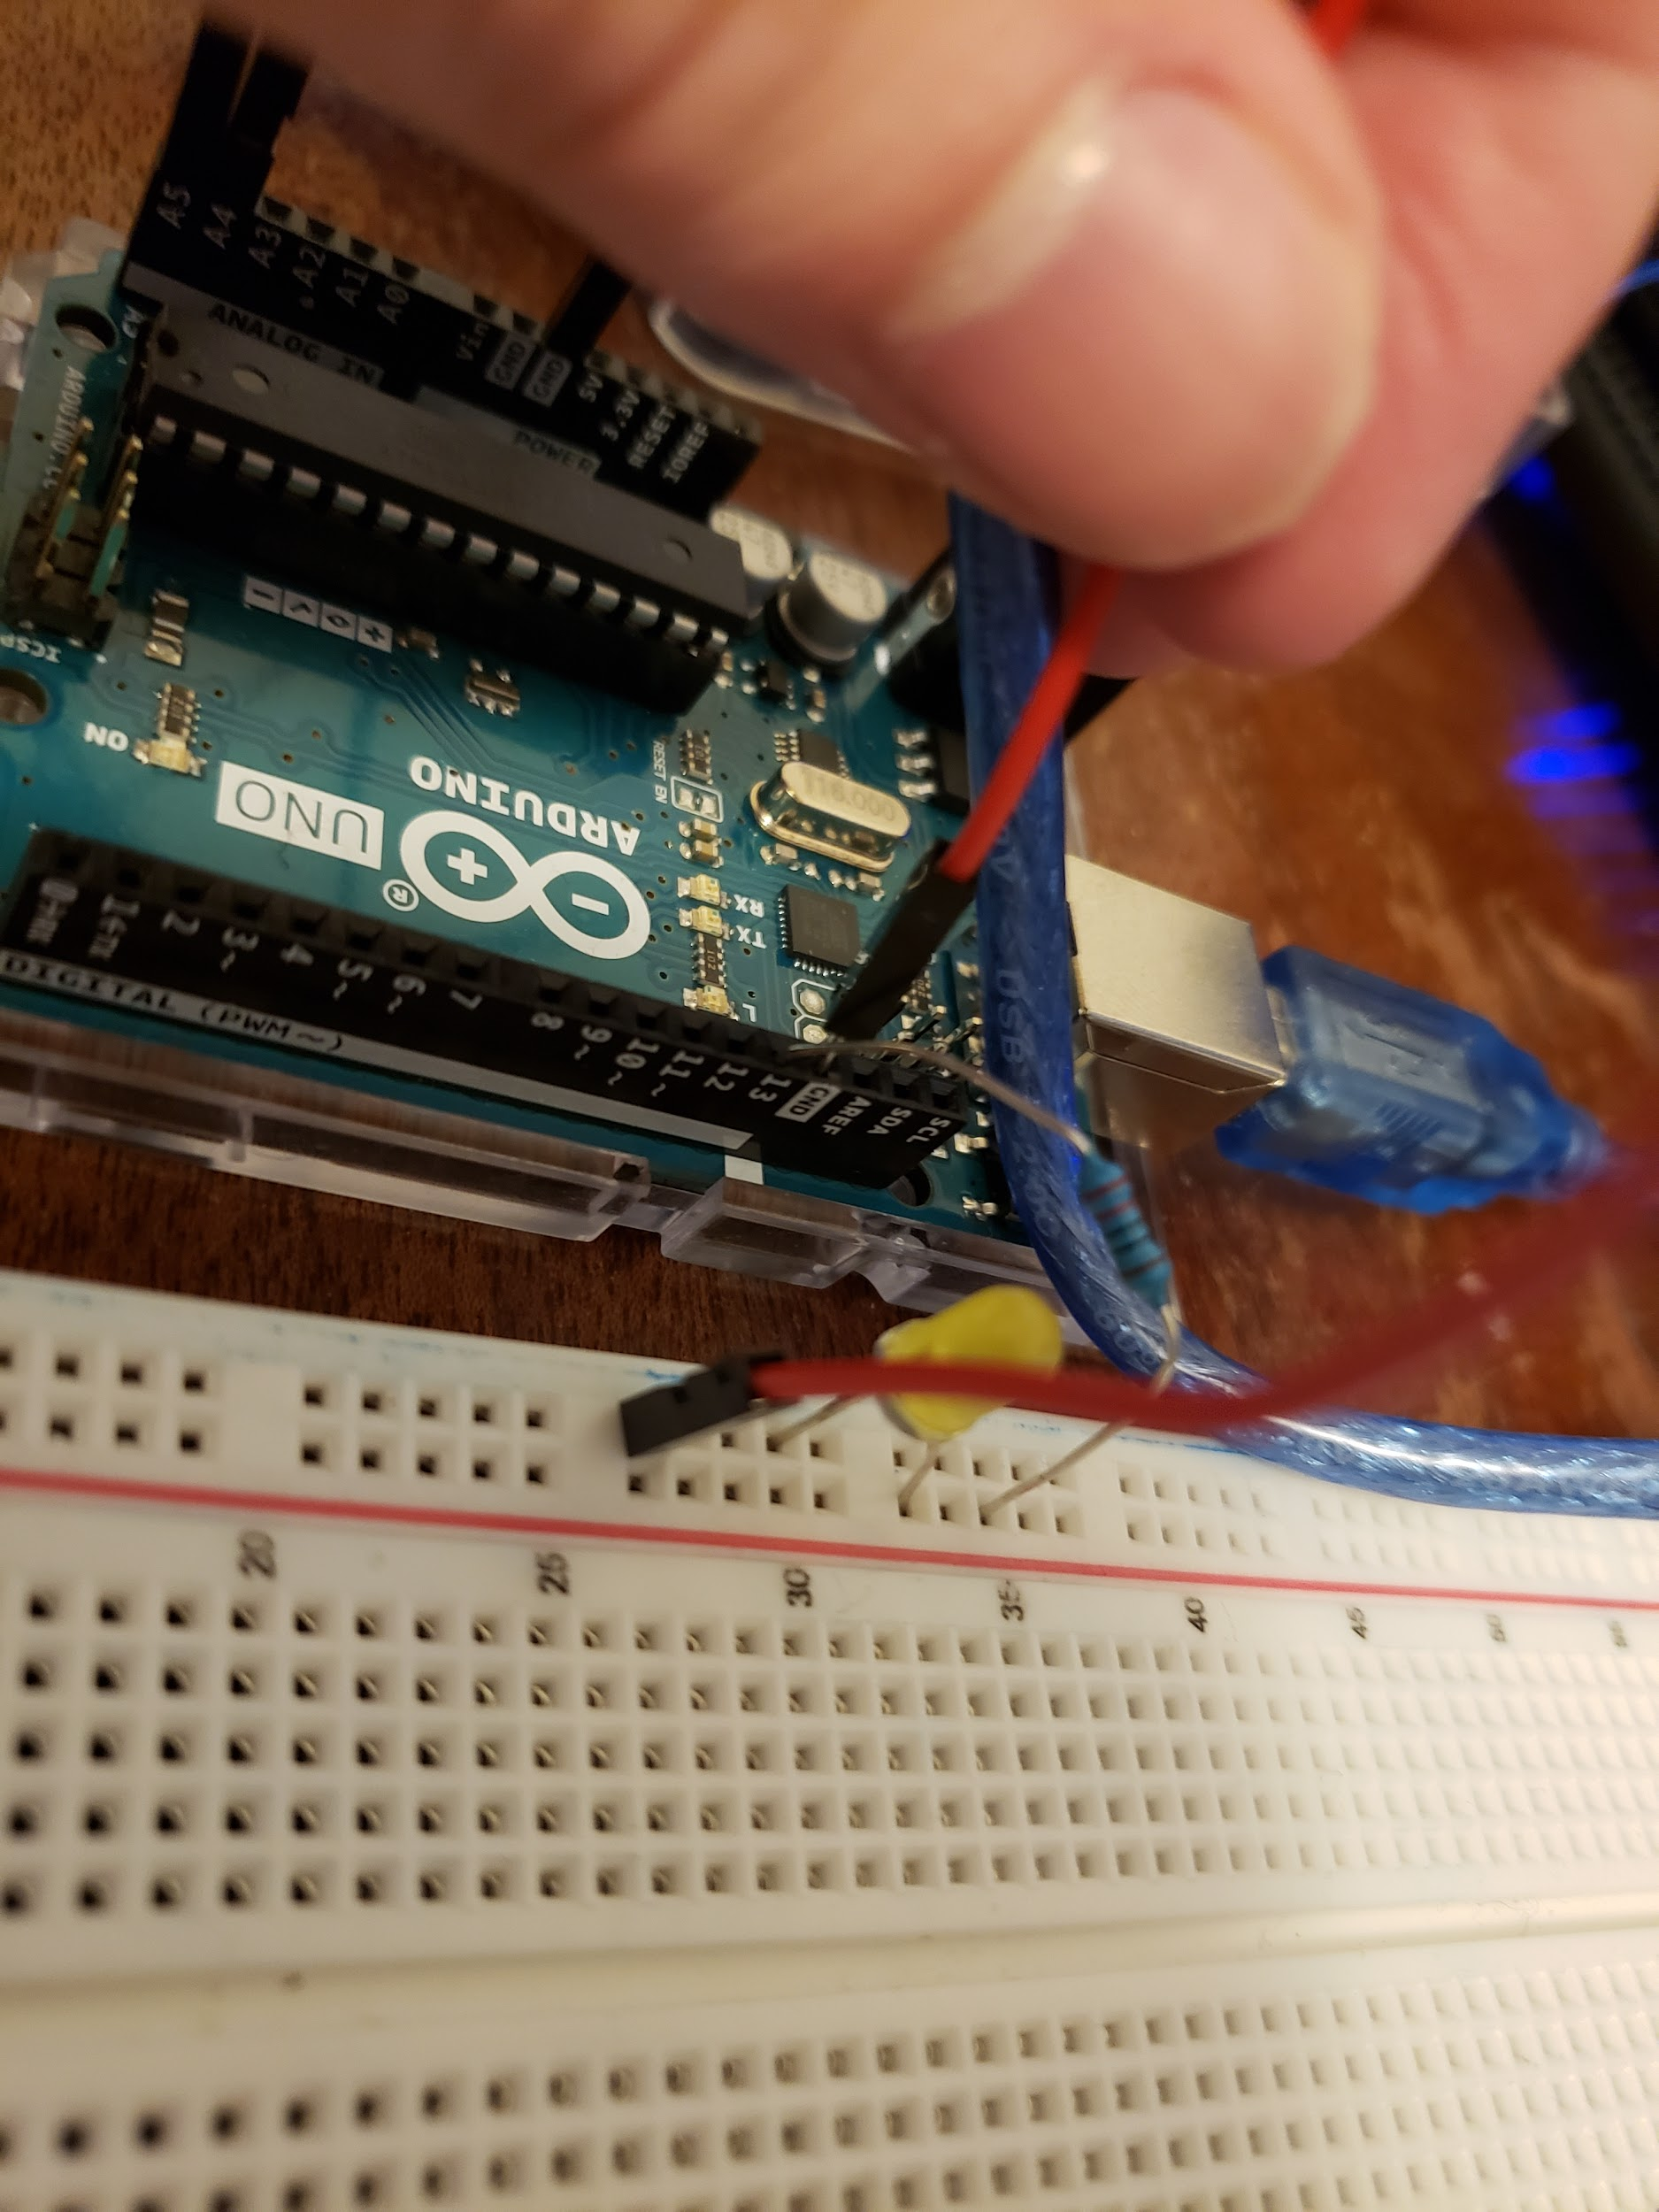

The wiring is now complete! The end product should resemble this:

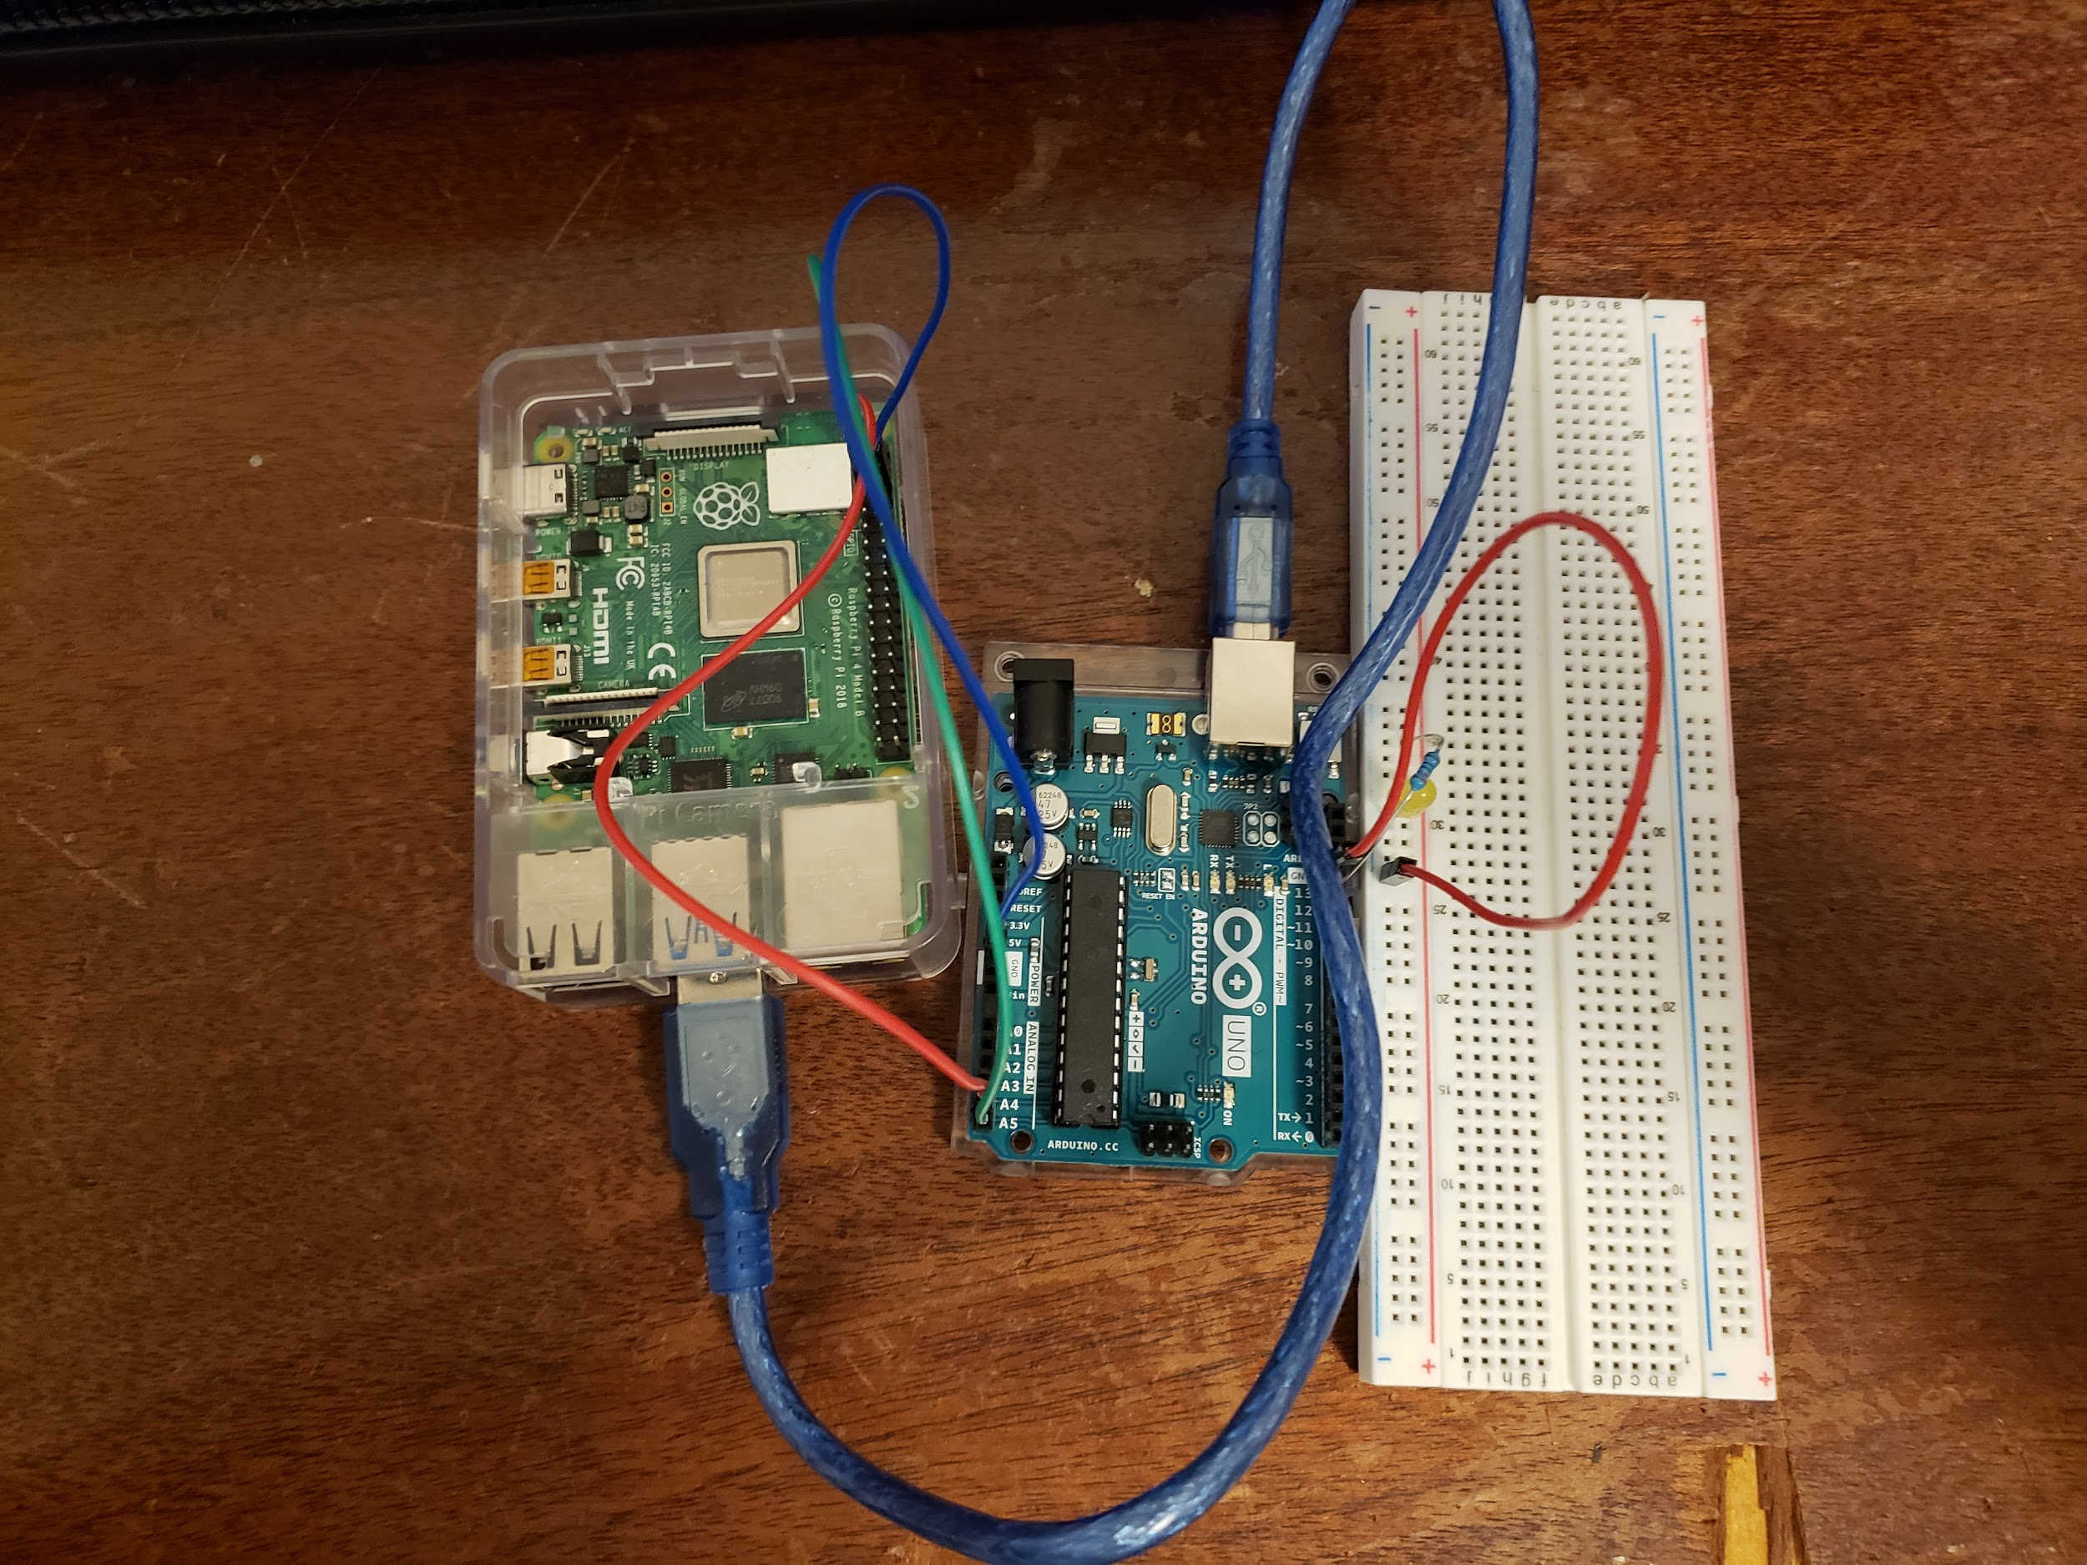

**The Second Step: Configuring Your Raspberry Pi**

By default this configuration will not work, as the I2C capabilities are initially turned off. To turn them on simply open up the command prompt on your Raspberry Pi.

First type: *sudo raspi-config*

That will bring you to this page:

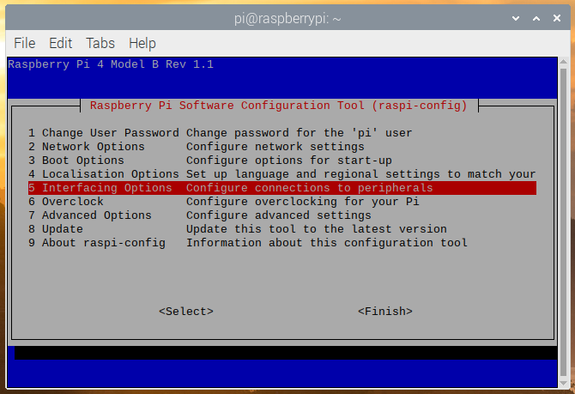

Scroll down to option 5 Interfacing Options and press enter. That will give you the option to enable the I2C connection. Once that is done, you can just press escape to get back to your command prompt.

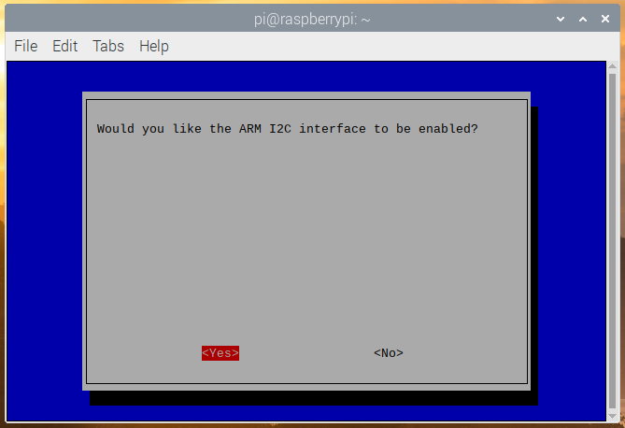

Once this is done, we must install the Arduino software on the Raspberry Pi. To do this simply type: *sudo apt-get update && sudo apt-get upgrade*

This will install some files and make sure your Raspberry Pi is up to date, once it is complete we can install the Arduino software.

Simply type: *sudo apt-get install arduino*

Once this is done, you are ready to program.

**The Third Step: Programming the Arduino and Raspberry Pi**

First make your way to the Arduino IDE, it should be in your applications under programming. Once there start with this simple program:

*#include <Wire.h>*

*const int ledPin = 13;*

*void setup() {*

*Wire.begin(0x8);*

*Wire.onReceive(receiveEvent);*

*pinMode(ledPin, OUTPUT);*

*digitalWrite(ledPin, LOW);*

*}*

*void receiveEvent(int howMany) {*

*while (Wire.available()) {*

*char c = Wire.read();*

*digitalWrite(ledPin, c);*

*}*

*}*

*void loop() {*

*delay(100);*

*}*

Once you have typed this out, simply save and upload it using the Arduino IDE.

Now we will create our python program for the Raspberry Pi, here is a sample of code for that:

*from smbus import SMBus*

*addr = 0x8*

*bus = SMBus(1)*

*numb = 1*

*print("Enter 1 for ON or 0 for OFF")*

*while numb == 1:*

*ledstate = input(">>>> ")*

*if ledstate == "1":*

*bus.write_byte(addr, 0x1)*

*elif ledstate == "0":*

*bus.write_byte(addr, 0x0)*

*else:*

*numb = 0*

With this done, you can run this python program from the command line or your IDE to see if it works. Ideally you should be able to press 1 to turn the LED on and 0 to turn it off. If you got stuck at any part of this tutorial, please reread the instructions or follow along with this video: <https://youtu.be/me7mhrRbspk> until about the 22 minute mark.

This is in theory the only thing you need to do to make use of the Arduino using a Raspberry Pi. The problem comes with when we attach additional sensors or devices onto the Arduino. The Arduino runs on a 5V logic level compared to the 3.3V logic level of the Raspberry Pi. This means if we connected any device with a pull-up resistor to 5V we run the risk of shorting our Raspberry Pi, thus “frying” it. To avoid this we can make a similar setup using a bi-directional logic level converter, that basically makes sure we don’t try to pull to much power out of the Raspberry Pi.

**The Fourth Step: Using a Bi-Directional Logic Level Converter**

To start simply remove the jumper wires between the Raspberry Pi and Arduino, leave the LED and the components needed to make it turn on in place. Your bi-directional logic level converter should have at least two channels for the two I2C pins. You also may need to solder the pins onto the board, it should look something like this:

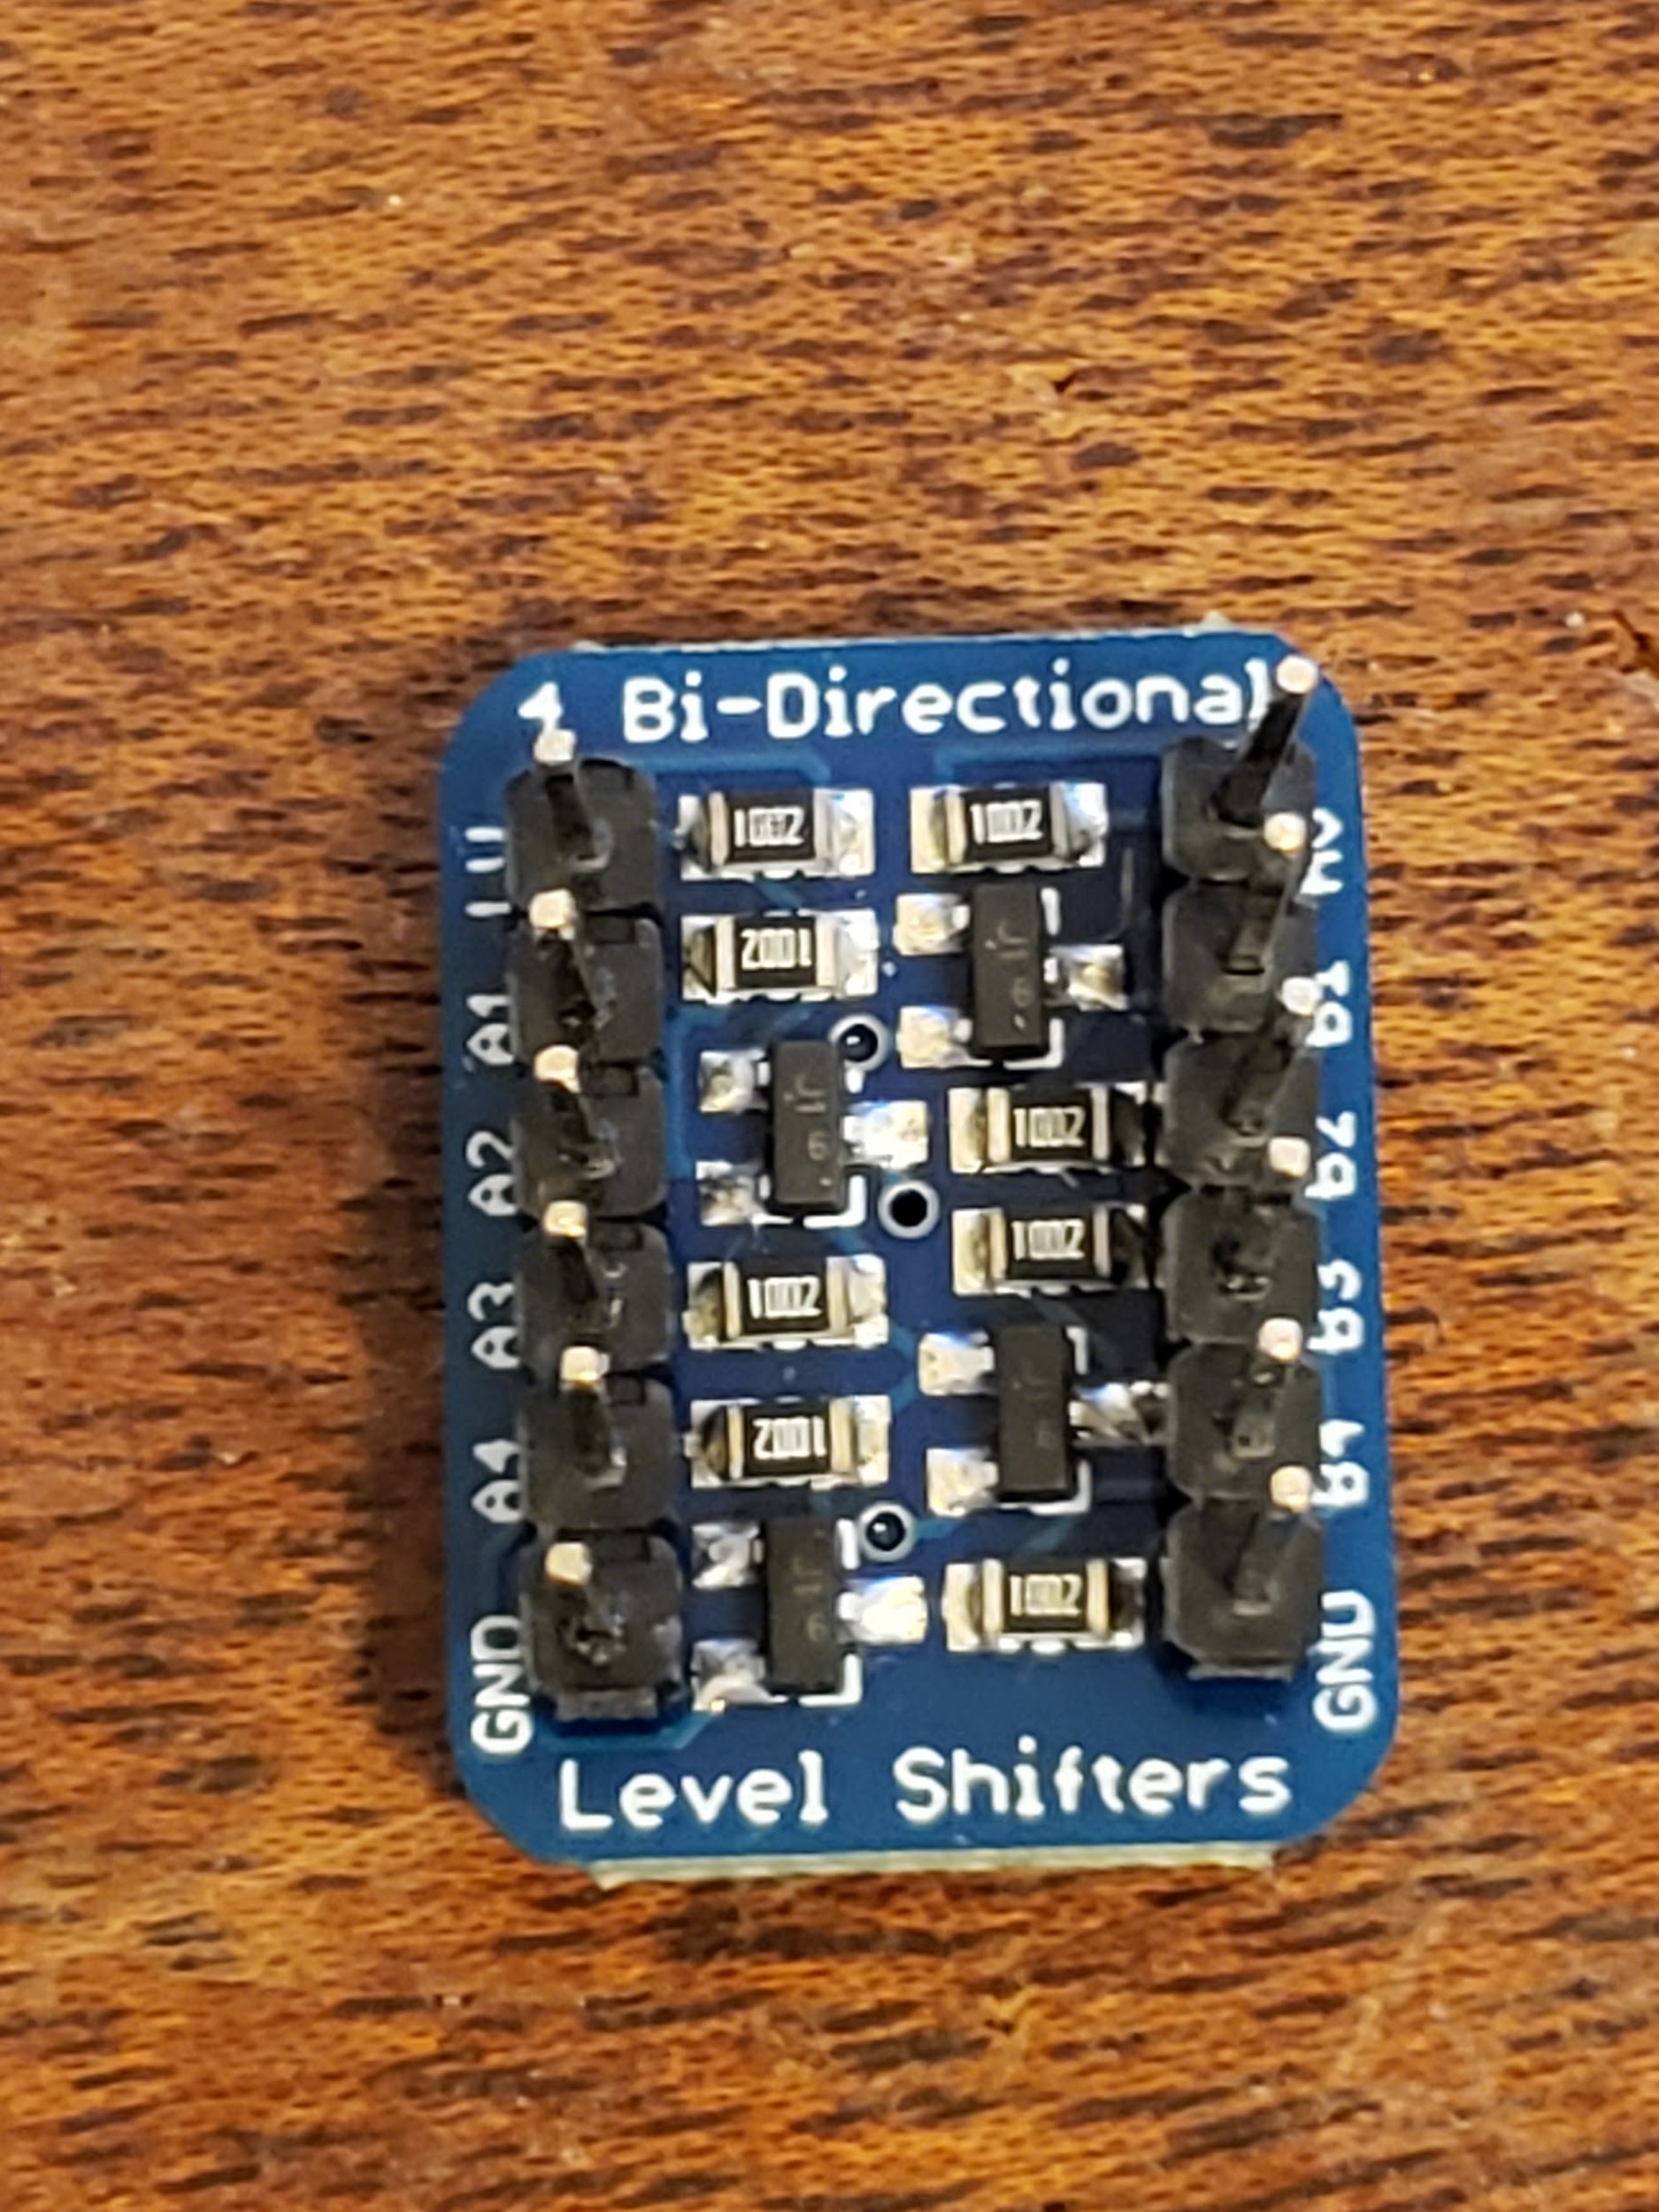

On the left side of the board you have 6 pins, LV, A1, A2, A3, A4, and GND. LV stands for low voltage this is the side you will connect to the Raspberry Pi since 3.3V < 5V. On the right side you have HV, B1, B2, B3, B4, and GND. HV stands for high voltage and will be the side that connects to the Arduino. The pins in between the voltage and ground are simply channels, this logic level converter has 4 channels. You will need to only use two of them though. Next you will need 8 total jumper wires, 4 will need to be female to female, and the other 4 will need to be male to female.

The female to female will be on the LV side and the male to female will be on the HV side.

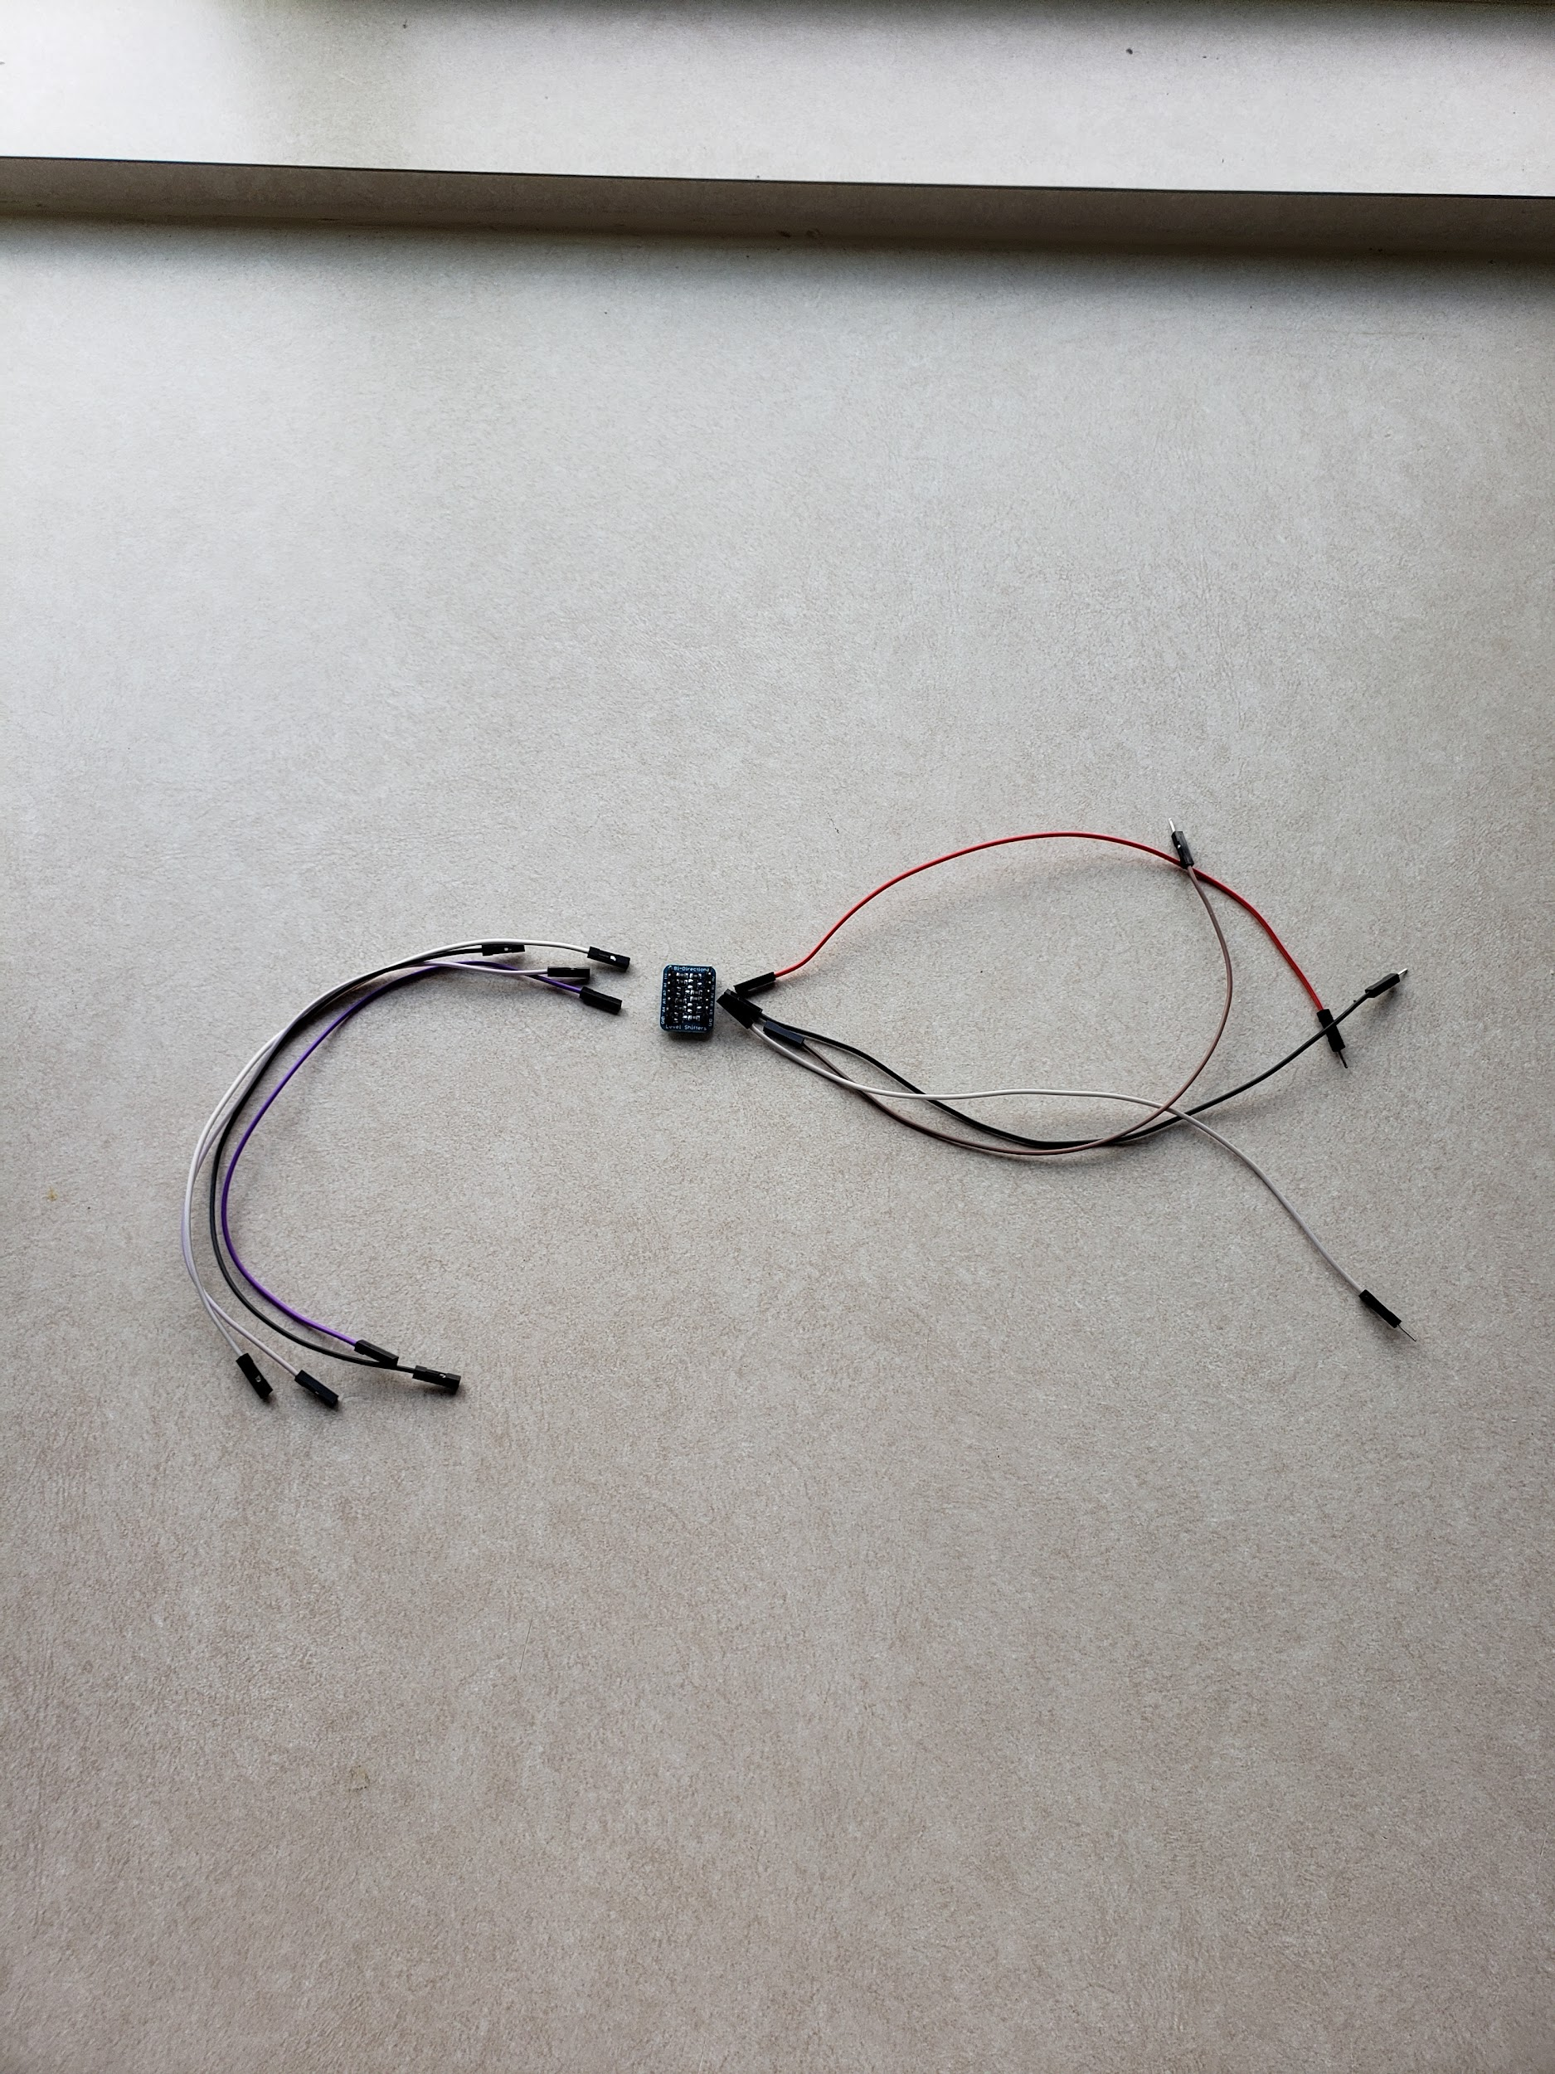

(everything you will need for the logic level converter)

Now simply plug the female ends into these corresponding pins, LV, A1, A2, and GND. A3 and A4 will be unused. On the right side plug the female ends into these corresponding pins, HV, B1, B2, and GND.

The LV and HV sides should look as follows:

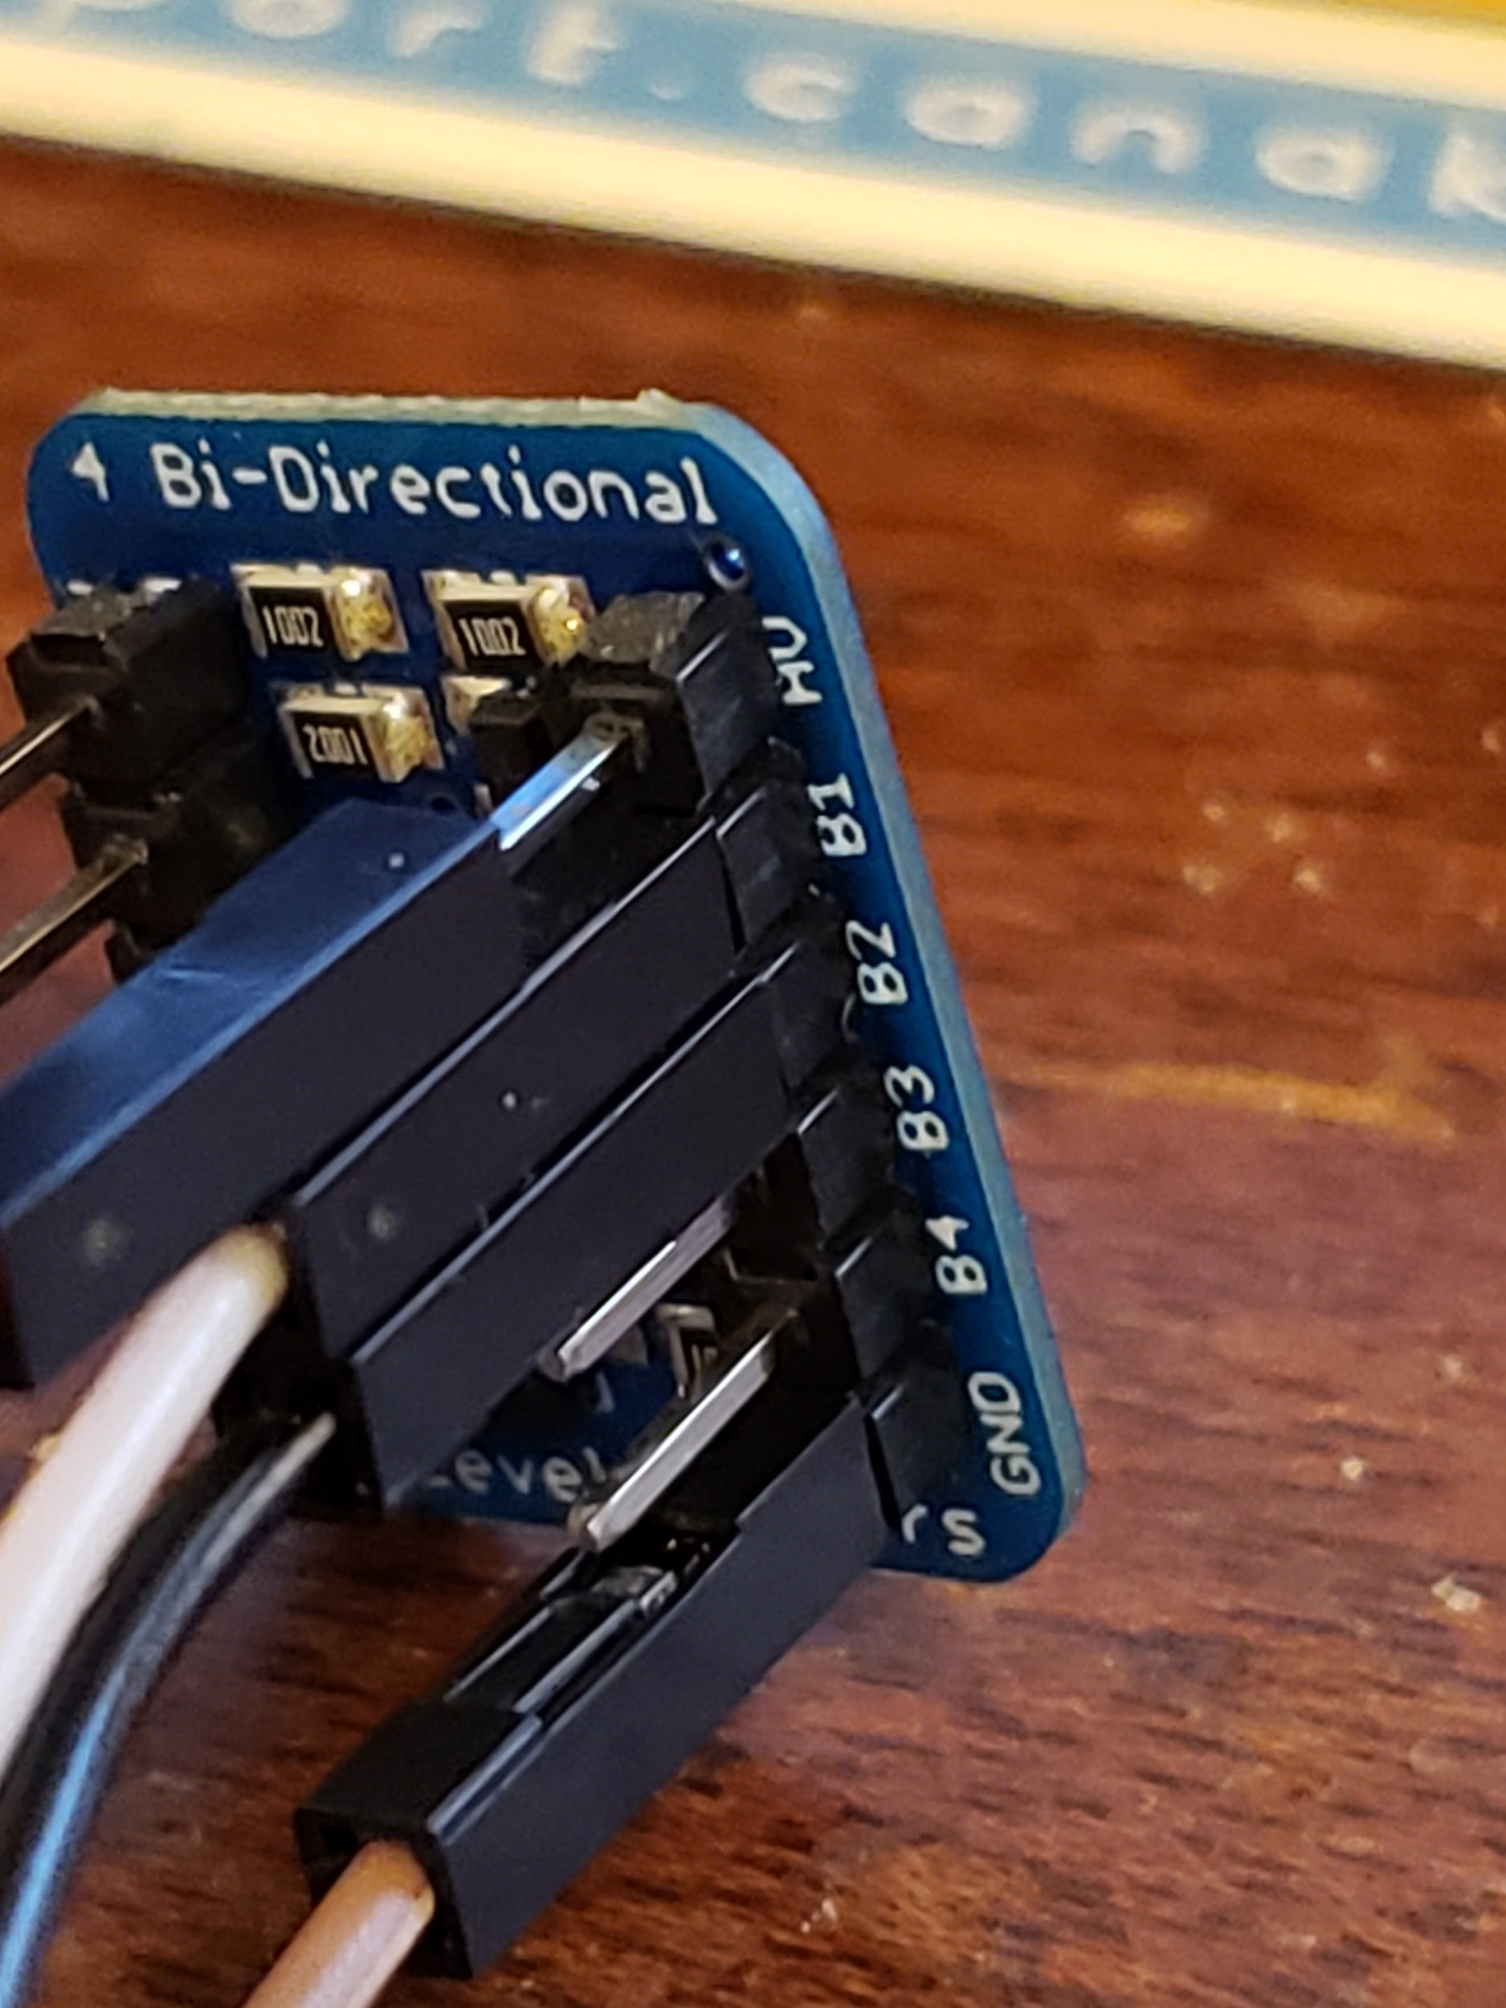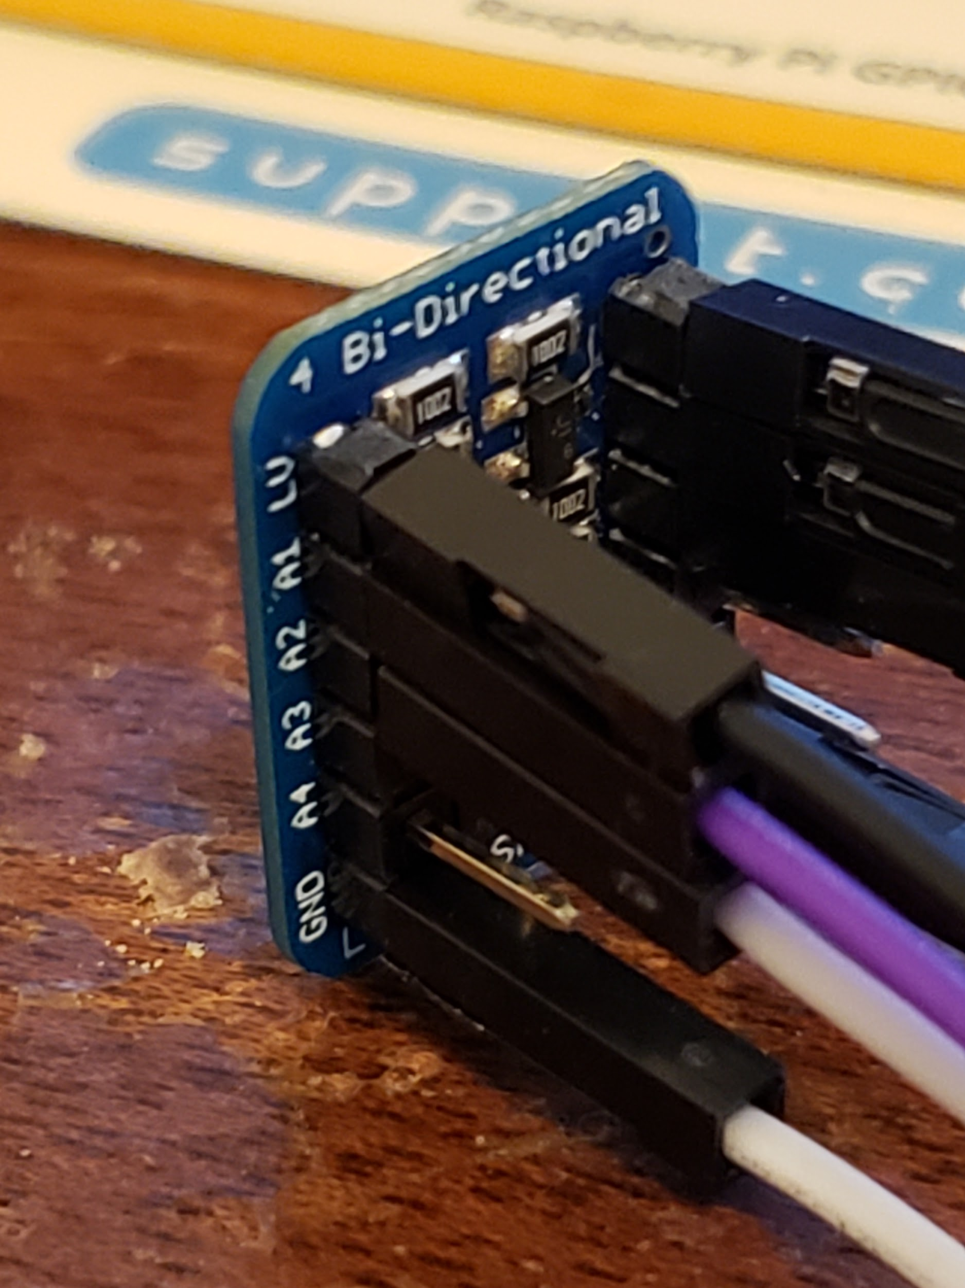

(HV side) (LV side)

We will start by hooking up the LV side into the Raspberry Pi, first plug the jumper that goes to the GND pin into a GND pin on the Raspberry Pi, for mine I chose pin 6.

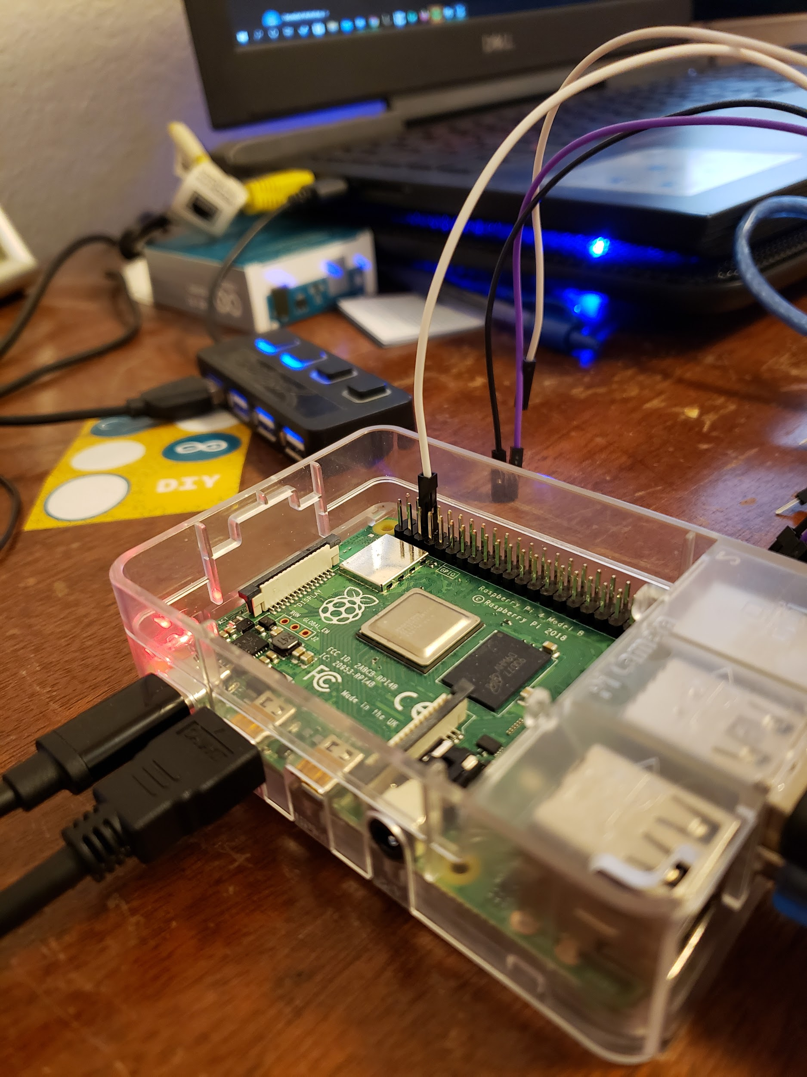

Next connect the jumper that is connected to A2 into the I2C SCL pin, that is pin 5. Also you can plug the jumper that is connected to A1 into the I2C SDA pin, that is pin 3.

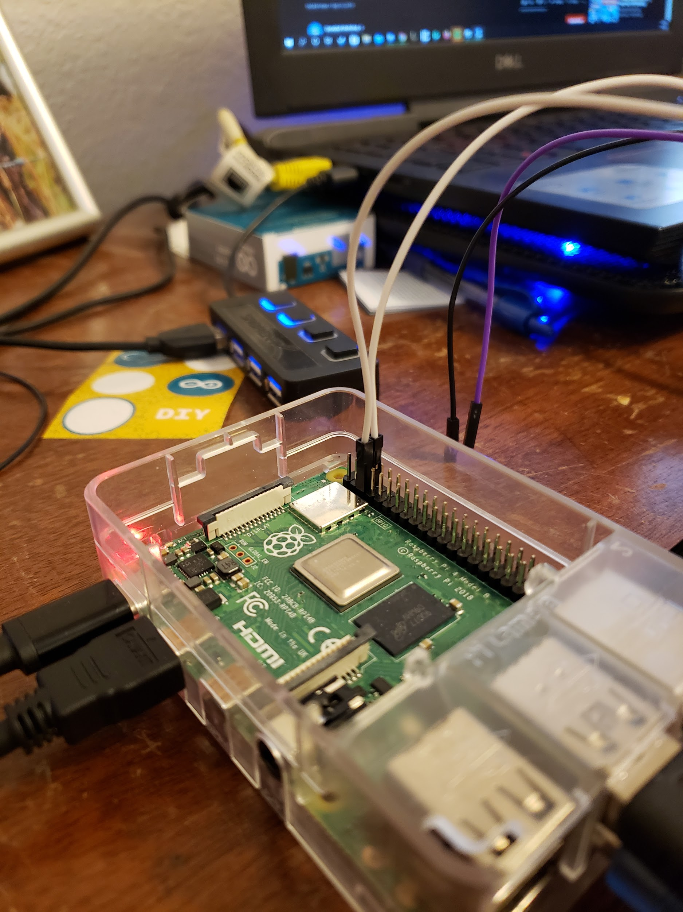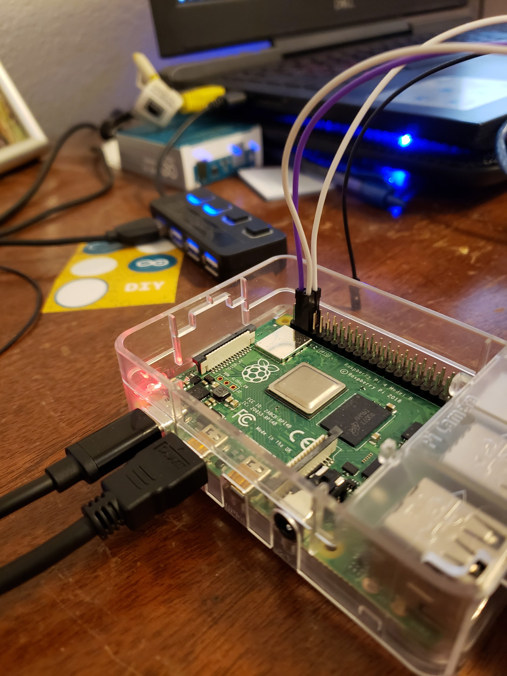

All that is left is to plug the LV pin into the 3.3V pin on the Raspberry Pi, this is pin 1.

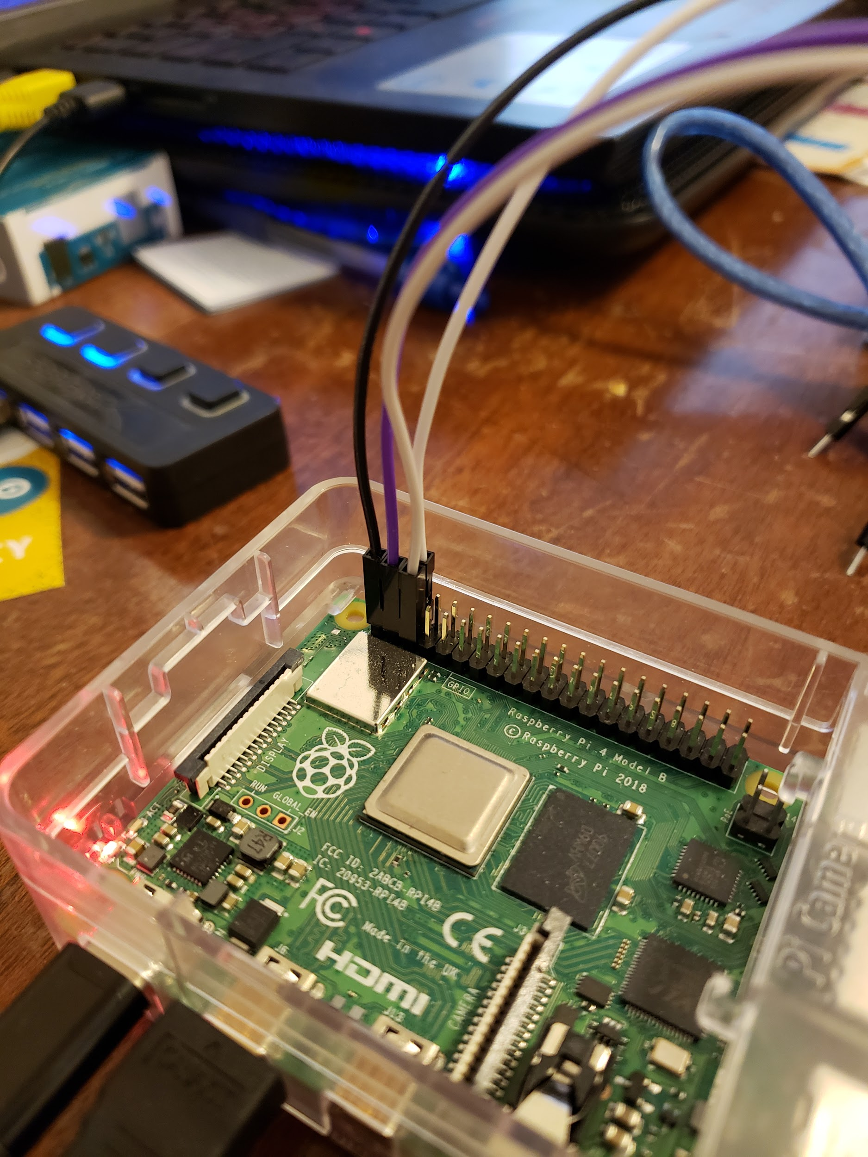

Once that is plugged in, you are done with the Raspberry Pi, moving to the Arduino we will be connecting the jumpers from B1 and B2 to A4 and A5 on the Arduino. Meaning B1 will connect to A4 and B2 will connect to A5 That should look something like this:

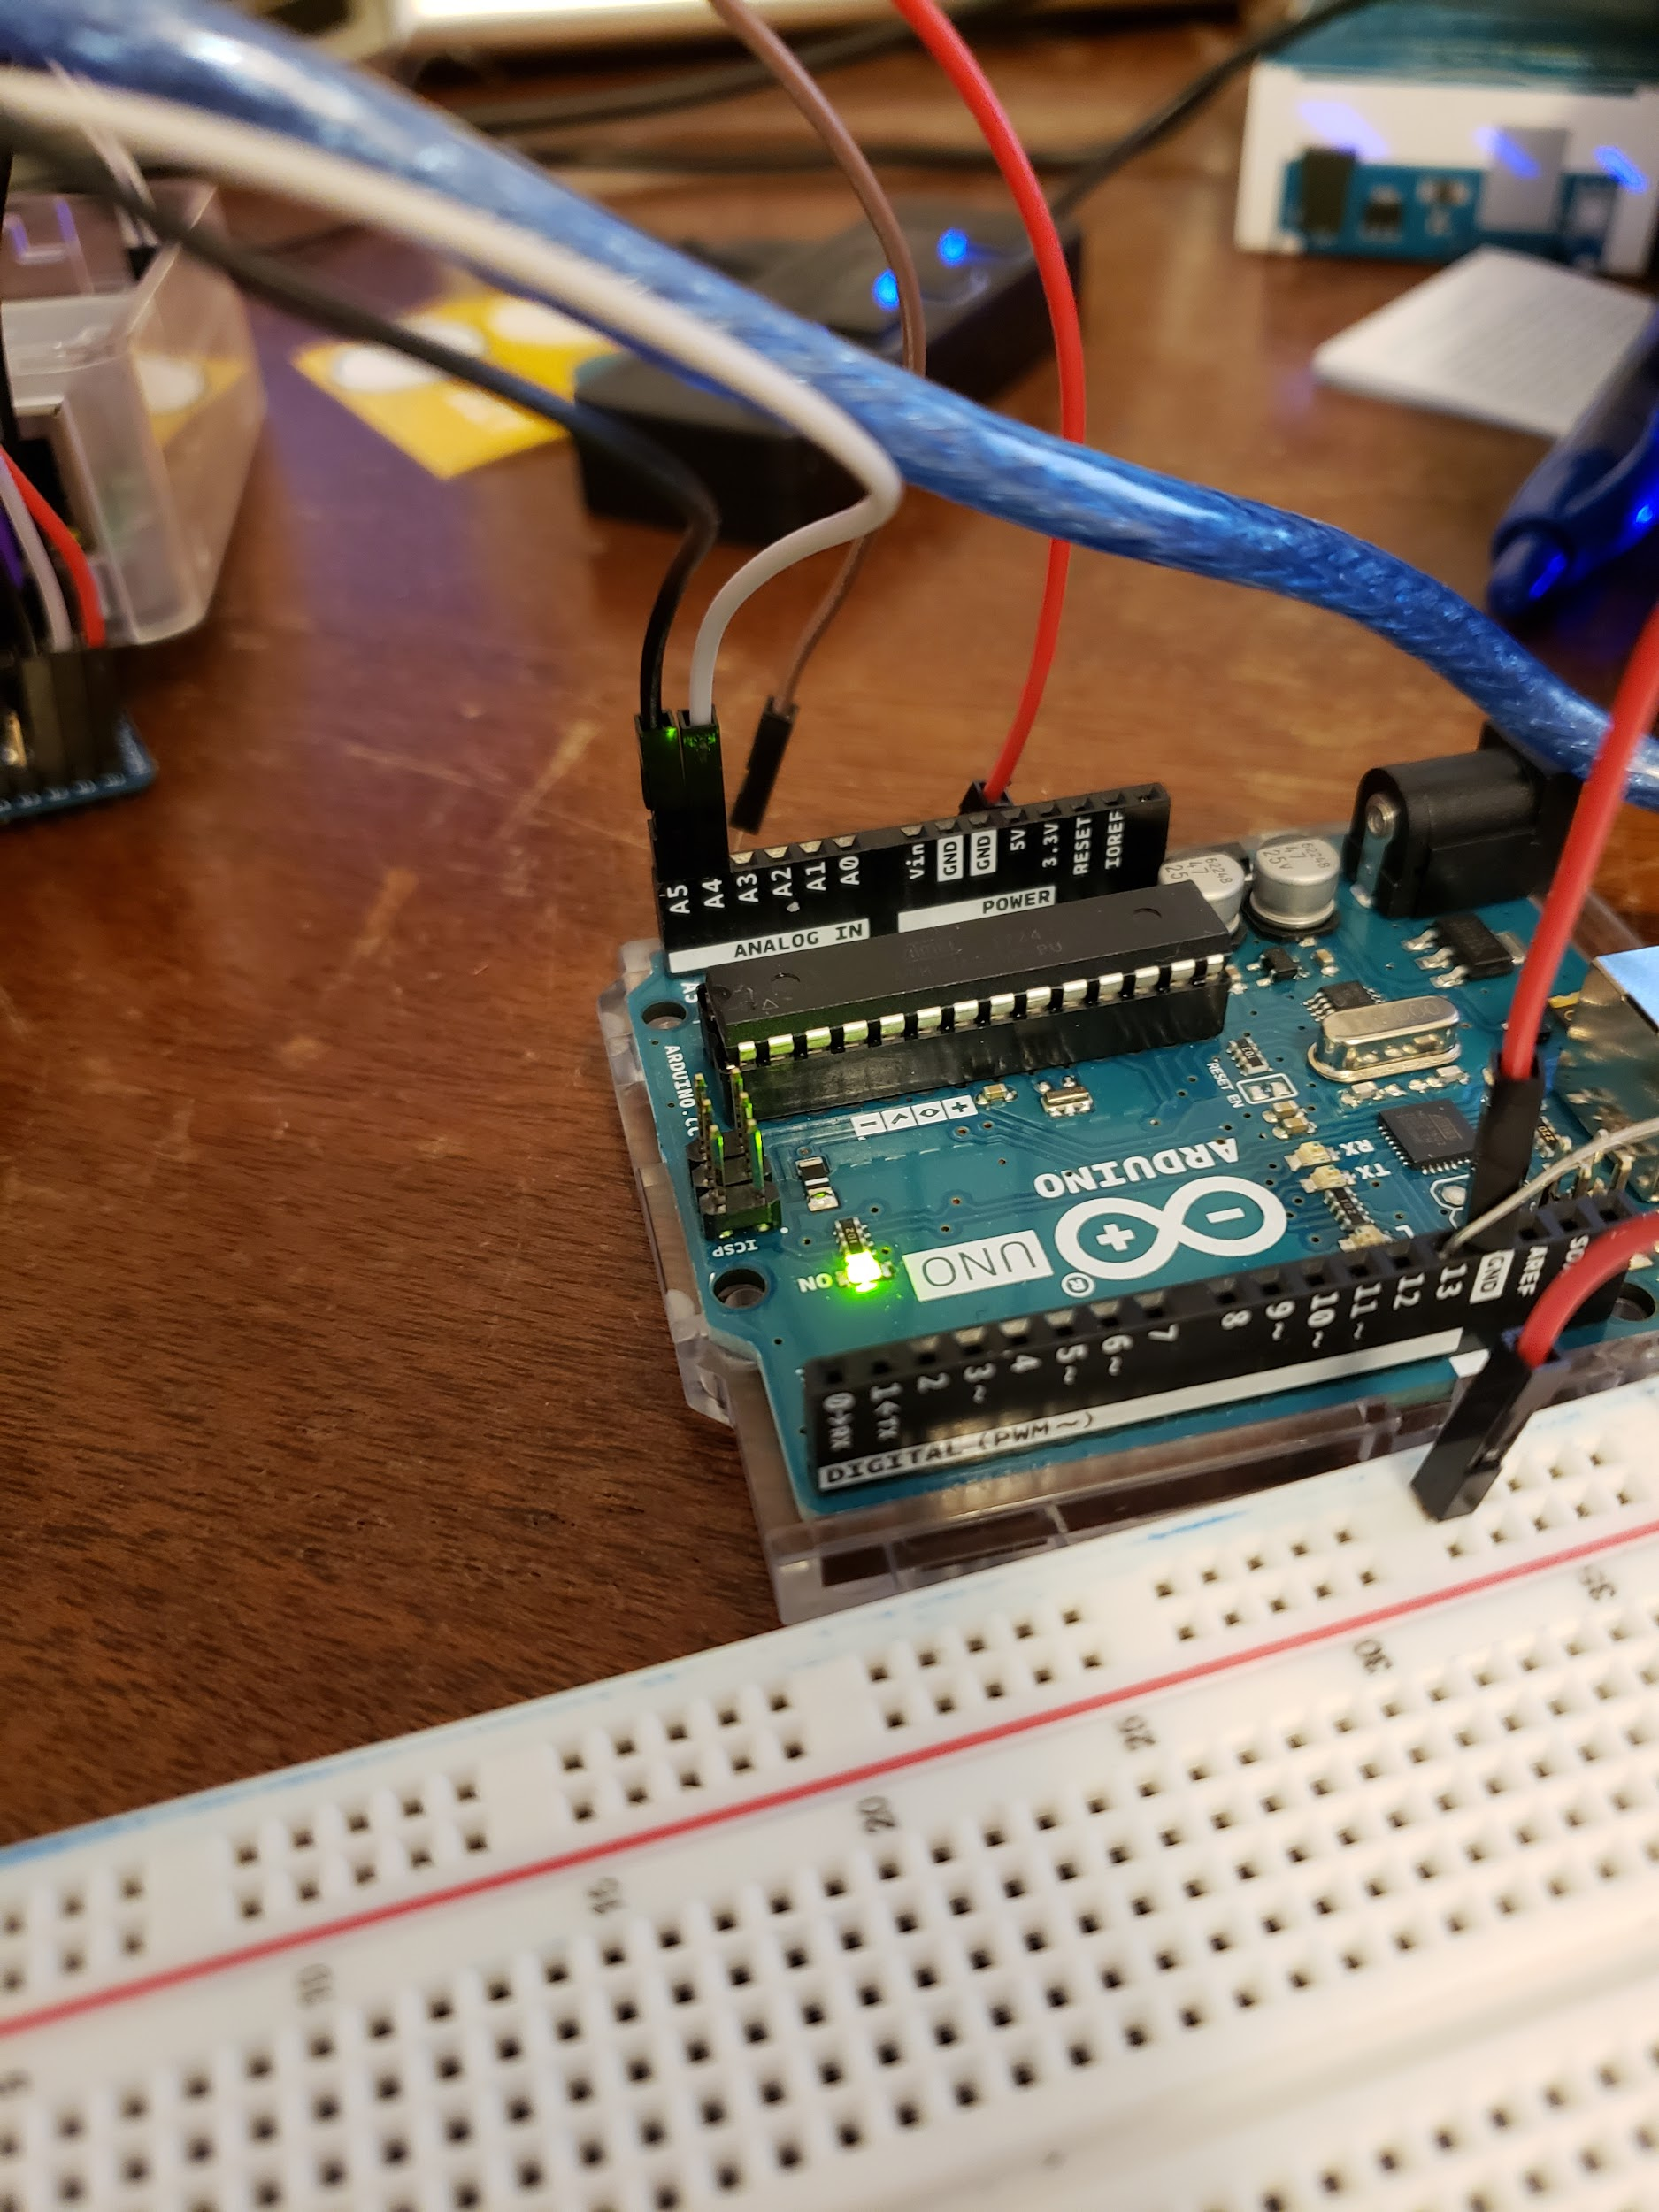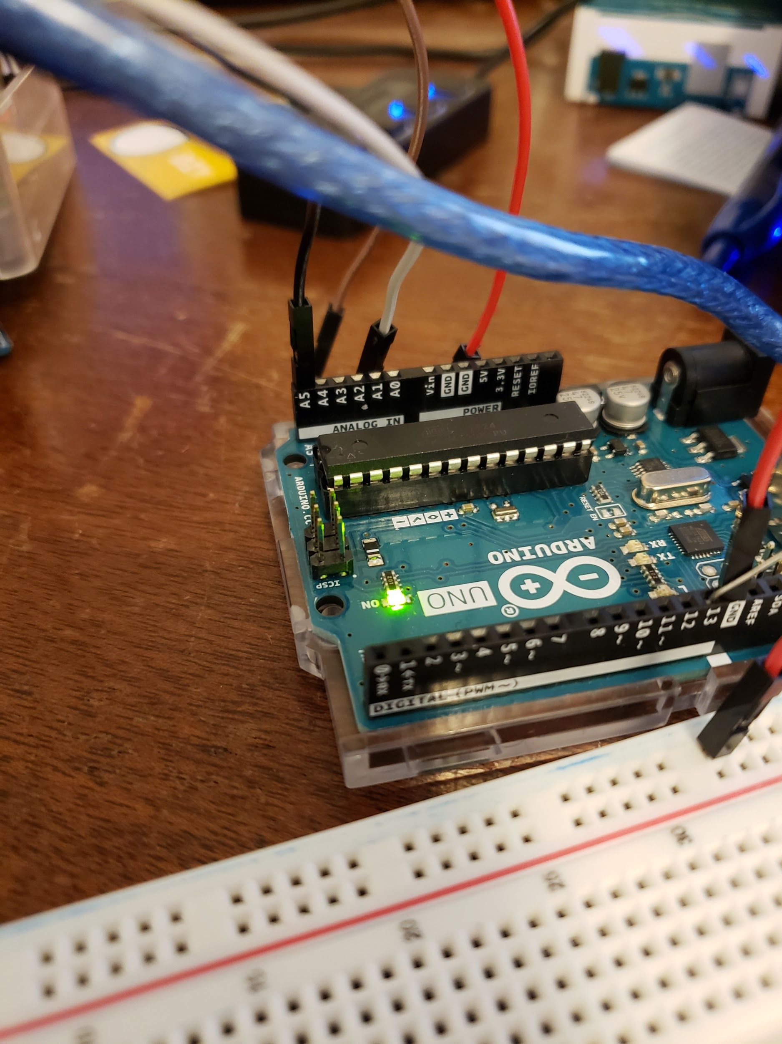

(with both connected) (only the B2 to A5 connection)

Next plug the jumper plugged into the GND pin into one of the GND slots on the Arduino.

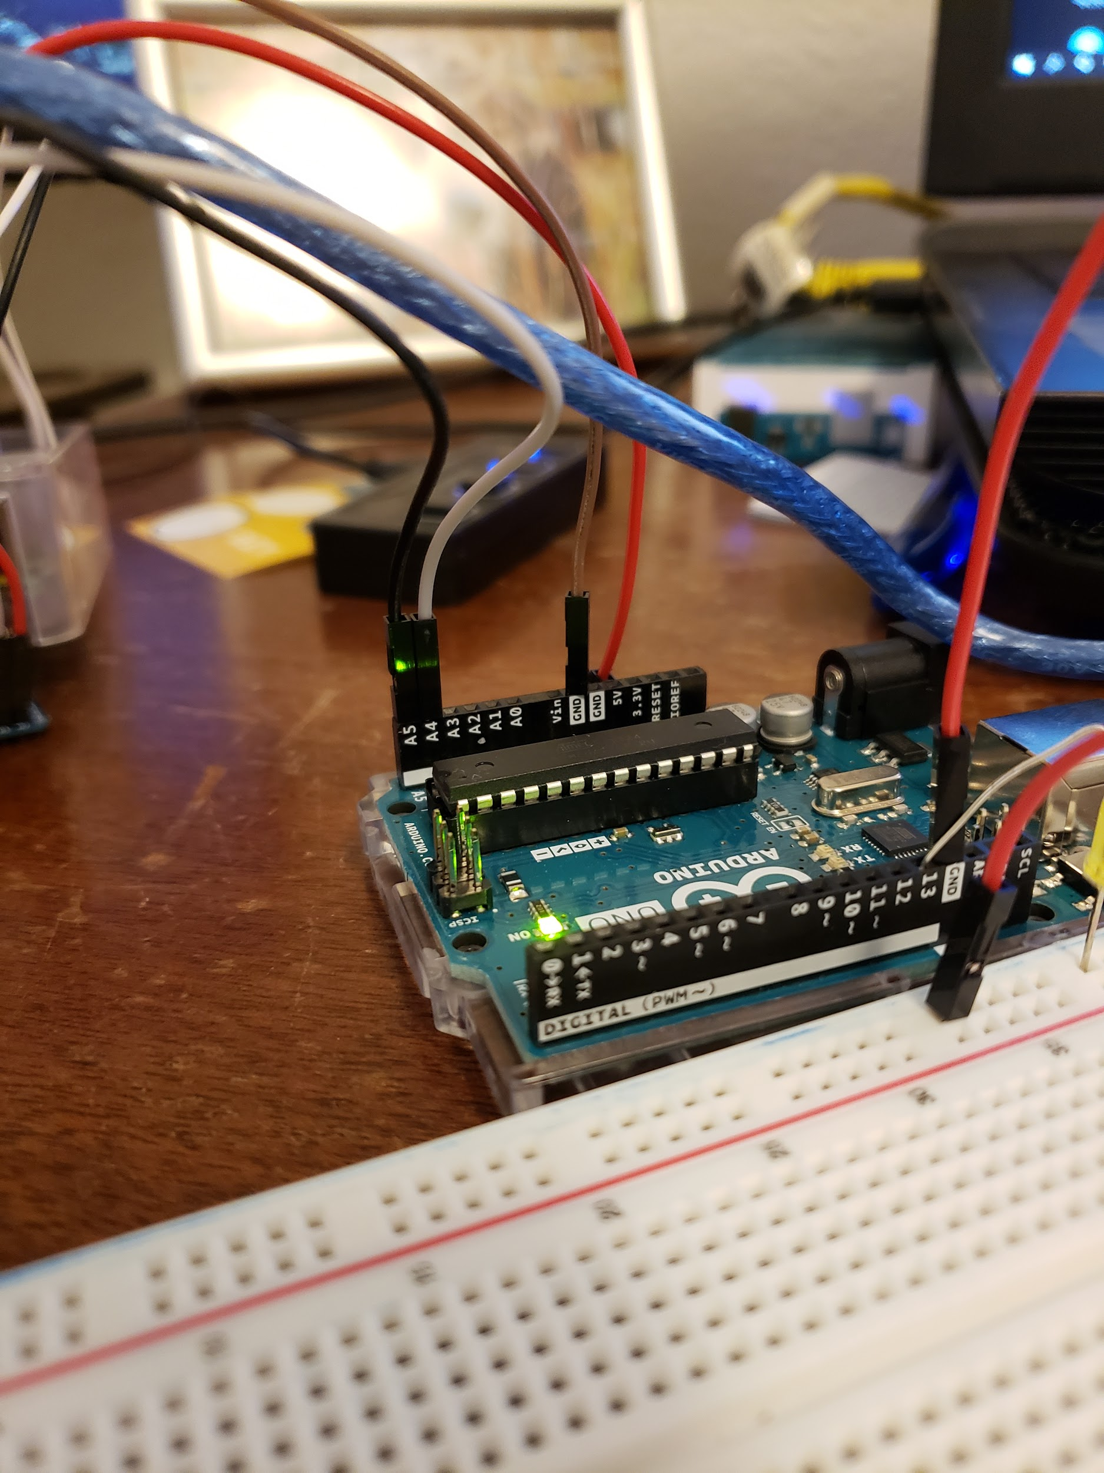

Lastly plug the HV pin into the 5V slot on the Arduino it should look something like this at the end:

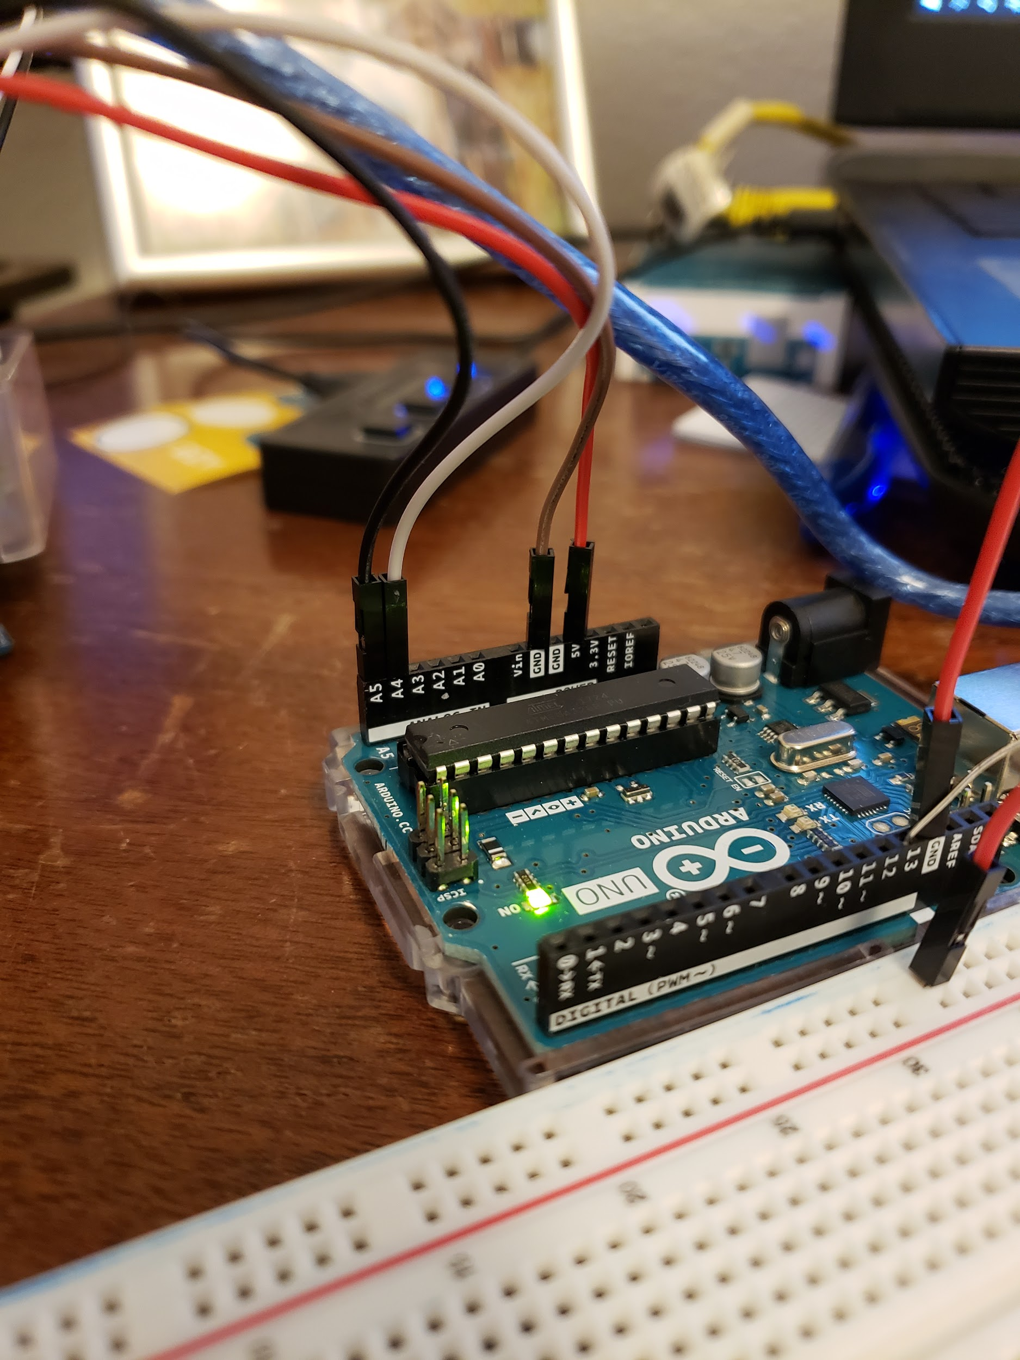

With that final connection made, you should be able to run the software we coded earlier and it should function in the exact same way it did before. If you got stuck at all in this last step please refer to this video starting at the 24ish minute mark.

Video: <https://youtu.be/me7mhrRbspk?t=1441>

This lab was heavily influenced by the video that has been linked throughout this document.

**PINS**

